Chapter 1
Overview of the California Next
Generation Science Standards

2016 Science Framework
for California Public Schools
Kindergarten through Grade 12

The CA Science Framework was adopted by the California State Board of Education on November 3, 2016.
The CA Science Framework has not been edited for publication. © by the California Department of Education.

Chapter 1
Overview of the California Next Generation Science Standards
Introduction
What is Three-Dimensional Science Learning?
Key Instructional Shifts for CA NGSS
Phenomena-Driven Three-Dimensional Learning
Coherent Instruction Across the Curriculum
Learning Relevant to Student Experience and Community Needs
The Three Dimensions in Depth
Dimension 1: Science and Engineering Practices
SEP-1 Asking Questions and Defining Problems
SEP-2 Developing and Using Models
SEP-3 Planning and Carrying out Investigations
SEP-4 Analyzing and Interpreting Data
SEP-5 Using Mathematical and Computational Thinking
SEP-6 Constructing Explanations and Designing Solutions
SEP-7 Engaging in Argument from Evidence
SEP-8 Obtaining, Evaluating, and Communicating Information
Dimension 2: Crosscutting Concepts
Historical Background and Global Context of the CCCs
CCCs in Brief
Using Crosscutting Concepts Through Framing Questions
CCC-1 Patterns
CCC-2 Cause and Effect: Mechanism and Explanation
CCC-3 Scale, Proportion, and Quantity
CCC-4 Systems and System Models
CCC-5 Energy and Matter: Flows, Cycles, and Conservation
CCC-6 Structure and Function
CCC-7 Stability and Change
Dimension 3: Disciplinary Core Ideas
Beyond the Three Dimensions
Environmental Principles and Concepts
The Role of Engineering Design, Technology, and Application of Science
The Engineering Design Process (ETS1)
Role of Engineering in Science and Society (ETS2)
When to Include Engineering in the Curriculum
Language Demands in a Three-Dimensional Learning Environment
Integrating the CA ELD Standards into K–12 Mathematics and Science Teaching and Learning
Interplay of Mathematics, Computational Thinking and CA NGSS
The Nature of Science and Understanding the Scientific Enterprise
21st Century Skills for California Citizens
How to Read the California Next Generation Science Standards
Performance Expectations
Foundation Boxes
Connection Boxes
CA NGSS Appendices
References

Introduction
The goal of the Next Generation Science Standards for California Public Schools, Grades Kindergarten Through Grade Twelve (CA NGSS) is to prepare California students to be future citizens and future scientists, which leads to a specific vision about science education:
Learning science depends not only on the accumulation of facts and concepts but also on the development of an identity as a competent learner of science with motivation and interest to learn more. […] Such identity formation is valuable not only for the small number of students who, over the course of a lifetime, will come to view themselves as scientists or engineers, but also for the great majority of students who do not follow these professional paths. Science learning in school leads to citizens with the confidence, ability, and inclination to continue learning about issues, scientific and otherwise, that affect their lives and communities. (National Research Council [NRC] 2012a, Chapter 11)

Achieving this vision for all California students requires that they build toward science mastery through repeated opportunities for meaningful, engaging, and successful learning experiences. To provide those experiences, the CA NGSS lays out a coherent progression for K–12 science based on accumulated research about science learning. Science is more than a disconnected sequence of facts—it requires understanding of the process of science, the fundamental ideas within each discipline of science, and certain underlying themes that are common to all the sciences. A Framework for K–12 Science Education (NRC Framework) identifies these components as three dimensions: 1) Science and Engineering Practices (SEP), 2) Disciplinary Core Ideas (DCI); and 3) Crosscutting Concepts (CCC). Figure 1.1 highlights how students must integrate these dimensions to understand them and solve problems to make that world better.
Figure 1.1. The NGSS Logo Illustrates the Three Dimensions of Science.
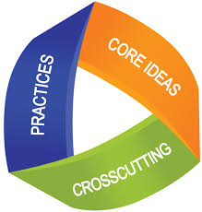
Source: NGSS Lead States 2013a

Science and Engineering Practices (SEPs) | Behaviors that scientists engage in as they investigate and build models and theories about the natural world and the key set of engineering practices that engineers use as they design and build models and systems.
Disciplinary Core Ideas (DCIs) | Key organizing concepts, problem solving tools, or underlying principles of a discipline.
Crosscutting Concepts (CCCs) | Underlying themes that have value in all disciplines of science.

Students achieve the vision of the CA NGSS when they live up to the statement placed at the beginning of the list of standards: “Students who demonstrate understanding can…” This statement requires that students know more than how to select the right answer. Instead, students are able to support their answer through the science and engineering practices or to apply their knowledge through those practices to new problem situations. To help students meet these expectations, progressive and coherent integration of the three dimensions of science learning needs to occur throughout curriculum design, instruction, and assessment of students (figure 1.2).
This chapter explains the three dimensions of learning from the NRC Framework and justifies the importance of teaching and learning science as a three-dimensional process.

Figure 1.2. Chapters in this Framework Describe How Effective Implementation of the CA NGSS Requires Many Elements
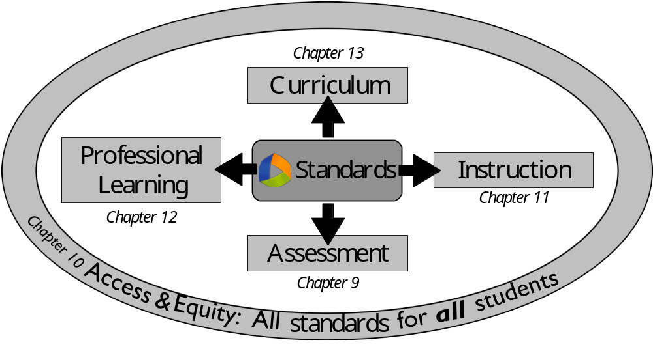
Diagram by M. d’Alessio

What is Three-Dimensional Science Learning?
Scientists have long recognized that building scientific knowledge is a multi-dimensional process. French philosopher Poincaré described this process by saying: “Science is built up with facts, as a house is with stones. But a collection of facts is no more a science than a heap of stones is a house.” (Poincaré 1905, 140–159) While all analogies have limitations, Poincaré’s house analogy can be extended to illustrate the three dimensions of science learning in the CA NGSS (figure 1.3).

Figure 1.3. Building a House as an Analogy for Three-Dimensional Learning
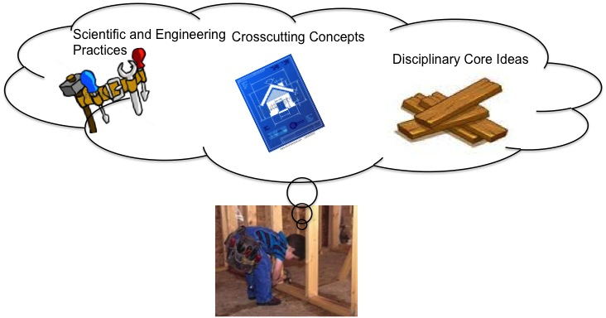
Diagram by M. Simani

Disciplinary Core Ideas (DCIs) are represented by planks and other building materials; students must be able to build upon their existing knowledge by connecting new ideas to this foundation. The science and engineering practices (SEPs) are the tools (hammer, saw, measuring tape, etc.) needed to build the structure and the skills needed to use them effectively. Finally, the crosscutting concepts (CCCs) are the common elements shared by all structures that influence their design and construction. The builder relies on a vision, mental model, or concept of structures in general and multiple aspects of how they work in order to interpret the house blueprint plans, choose and use the materials appropriately, and do the work of building the house appropriately and efficiently. For example, builders recognize patterns in the way walls are constructed using horizontal and vertical support structures, are mindful about interactions between different subsystems in the home such as electrical and plumbing, and consider the scale of the project when deciding what equipment to use. These unconscious habits of mind might allow a builder to recognize an error in an architect’s drawing in much the same way that the CCCs allow scientists to conduct inquiry effectively. Without all these three sets of components – building materials, building practices, and general concepts about homes, builders cannot construct a usable and durable structure. Any part of the building activity requires using all three components in their distinct but equally critical roles.

California’s 1998 Science Standards emphasized the building materials, the DCIs. Clearly one cannot build a house without materials, but like Poincaré’s pile of stones, these are not enough. The NRC Framework and the NRC report Taking Science to School (NRC 2007) present research that shows that the knowledge structure of scientists is highly developed and interconnected; it includes not just scientific facts and theories, but also the connections between them and the contexts in which they are useful. Relating this expertise in science to the analogy of a master builder, different tools and different building practices are needed at different stages of the building process or when using different materials. The builder who has experience with a variety of different buildings develops expertise to know which tools and practices are most useful in various contexts, and to select them flexibly and appropriately when faced with a new problem. Students must gain access to not just building materials (the established ideas of science described in the DCIs), but they must also learn to use the tools of the SEPs and the skills needed to carry these practices out effectively. Further they need the CCCs to selectively make connections between ideas and thus develop a comprehensive and interconnected knowledge structure.
The CA NGSS are explicitly organized around both the tools (SEPs) and the overarching principles (CCCs) of science because of the overwhelming research on learning showing the importance of organizational structures for helping students progress to become experts. The benefit is not just theoretical: standards based on unifying ideas are common in other countries that produce significant scientific innovations and score highly on international benchmark tests (Achieve 2010). Students who develop a perception of science knowledge similar to that of scientists are more likely to persist in science learning and to study more science. To build such a conceptual structure of science knowledge, students need to develop capacity with all three dimensions of science learning.
The teacher’s role is to provide students with the materials (DCIs), the tools and how to use them (SEPs) and the vision of interconnectedness (CCCs). Over multiple years, students’ knowledge structures will need to be improved and even rebuilt as their experiences linking all three dimensions of the CA NGSS lead to a more realistic understanding of the work that scientists and engineers accomplish (table 1.1).

Table 1.1. The Three Dimensions of the CA NGSS
Science and Engineering Practices  - Asking questions and defining problems  - Developing and using models  - Planning and carrying out investigations  - Analyzing and interpreting data  - Using mathematics and computational thinking  - Constructing explanations (for science) and designing solutions (for engineering)  - Engaging in argument from evidence  - Obtaining, evaluating, and communicating information | Disciplinary Core Ideas  Physical Science  PS1: Matter and its interactions  PS2: Motion and stability: Forces and interactions  PS3: Energy  PS4: Waves and their applications in technologies for information transfer  Life Science  LS1: From molecules to organisms: Structures and processes  LS2: Ecosystems: Interactions energy, and dynamics  LS3: Heredity: Inheritance and variation of traits  LS4: Biological evolution: Unity and diversity  Earth and Space Science  ESS1: Earth’s place in the universe  ESS2: Earth’s systems  ESS3: Earth and human activity  Engineering, Technology, and Applications of Science  ETS1: Engineering Design  ETS2: Links among engineering, technology, science, and society | Crosscutting Concepts  - Patterns  - Cause and effect: Mechanism and explanation  - Scale, proportion, and quantity  - Systems and system models  - Energy and matter: Flows, cycles, and conservation  - Structure and function  - Stability and Change
Teachers need to both monitor student progress using three-dimensional classroom assessments and provide students opportunities to explicitly reflect on their understanding of the relationship between these three dimensions. Through this process, students will master core ideas in science and also understand how that knowledge has been acquired and how they can apply it to new situations.

Key Instructional Shifts for the CA NGSS
When teachers integrate all three dimensions of the CA NGSS, their classrooms look different. Table 1.2 shows a few examples of how the actions of both teachers and students change. These shifts occur because the CA NGSS instruction is:
- Three dimensional. Students engage in scientific inquiry of phenomena using all three dimensions of the CA NGSS.
- Coherent across the curriculum. Learning builds upon itself from year to year and science integrates with other parts of the curriculum.
- Relevant to local communities and student interests. Content and skills build on students’ existing experience to learn about and solve real-world problems.
Both the NRC Framework and the CA NGSS highlight a vision for student learning centered on the development of practices and knowledge that will transfer beyond the classroom and beyond formal K–12 schooling. In particular, the aim is to prepare all students graduating from high school to be critical consumers of information and capable problem-solvers and to engage in public discussion using evidence-based argumentation across a broad range of topics.
Transferable and deeper learning opportunities for students supported by instructional practices create a positive and engaged community both inside and outside of the classroom. In these contexts, students develop content knowledge while also assessing the development of their own communication, collaboration, and self-direction, also known as twenty-first-century skills. The explicit link between the CA NGSS and twenty-first-century education will be discussed at the end of this chapter.
Table 1.2. Instructional Shifts Required by the CA NGSS
More of this… | Less of this…
Students engage in the CA NGSS practices to build deeper understanding of science and engineering content and make sense of phenomena and design solutions. | Students study the meaning of science content that teachers explain to them. Students memorize definitions and rote procedures.
Students develop models of systems within the natural world and use them to explain phenomena or solve problems. | Teachers present models that describe phenomena in the natural world.
Students learn science as an iterative, dynamic, creative, and collaborative process similar to how real scientists and engineers do their work. | Students learn science as a collection of facts and learn that these facts were found using a singular and linear “scientific method,” disconnected from how real scientists and engineers do their work.
Practices provide students with relevant, real-world learning in which they must investigate and problem-solve using critical thinking. | Students learn to conduct investigations following step-by-step instructions.
Students build science and engineering understanding using a variety of practices in investigations, experiments, and project-based experiences. | Student use one practice per investigation/experiment.
Science content and science practice are integrated. | Science content and practices are taught in isolation.
Student reasoning and argumentation play a central role in understanding labs and text. | Student thinking is limited by a “cookbook” approach to lab experiences and problems or end-of-the-chapter questions and test experiences.
Science and engineering notebooks reflect student thinking using the science and engineering practices to understand content and show development and revision of student’s scientific models. | Science notebooks reflect only students’ ability to take notes or copy teacher models.
Engineering is integrated into all science disciplines. | Engineering is treated as an add-on.
Engaging in science and engineering practices allows students to revise their thinking and understanding. | The science process is just something to learn/apply and “be done.”

Students are actively engaged in the practices through investigations and experiments and technologies they have generated. | Students are passively engaged in watching or participating in teacher- directed investigations and experiments.
Crosscutting concepts build deeper and connected understanding of science as a whole. | No connection is developed among science content.
Connection of the practices to the goals of literacy in science (purposeful reading, writing, speaking, and listening to strengthen science understanding) is fostered. | Reading and writing are disconnected from the purpose of learning.
Student-to-student discourse is productive, using practices to explain phenomenon or solve problems | Student-to-student discourse is limited due to activities that provide only one exact outcome.
Teacher questioning prompts and facilitates students’ discourse and thinking. | Teacher questions students to seek a confirmatory right answer.

Phenomena-Driven Three-Dimensional Learning
A fundamental principle in CA NGSS is that students must use the three dimensions to understand specific phenomena, and that phenomena drive science learning. The word phenomenon (plural phenomena) in science means any observable event that occurs in a natural or a designed system. A ball bouncing is just as much a phenomenon as is a volcano erupting. CA NGSS instruction begins by introducing phenomena, and lessons progress as students apply each of the three dimensions to understand and explain the phenomena. In the process, students add to their library of what they know (DCIs), extend their ability to do science (SEPs), and broaden their way of thinking (CCCs).
Students are not expected to fully explain phenomena in a single class session or even a single grade level – this may be a major shift for many students. Students are, however, expected to make progress towards understanding a phenomenon by authentically engaging all three dimensions of science. Progress in science includes everything from recognizing a pattern [CCC-1] and asking a new question [SEP-1] to developing a sophisticated model [SEP-3] that explains [SEP-6] a phenomenon and successfully predicts new ones. Even when students do explain a phenomenon at one level of sophistication, they often revisit the same phenomena at a later grade level and are then able to explain it at a deeper level.
Students grapple with a particular phenomenon in different ways during instruction. Some phenomena are rich and complex enough that they can motivate learning for an entire instructional unit. These anchoring phenomena inspire students to ask questions [SEP-1] and motivate more detailed investigation [SEP-3]. They also serve as a platform for reflecting on learning as students revisit an anchoring phenomenon throughout instruction and apply their new understanding. Other phenomena are simpler and focus investigation [SEP-3] for individual activities (investigative phenomena). Observable phenomena sometimes introduce a specific problem that motivates specific engineering solutions (investigative problems). While all phenomena ideally should be relevant to students’ life, culture, and experience, sometimes instruction draws attention to specific events that occur in everyday life (such as, “Smells travel across the room”). Students may not directly investigate these everyday phenomena, but they can ask questions about them or apply their scientific understanding to explaining them. In some senses, the distinction between anchor, investigative, and everyday phenomena is subjective and relates to the scale [CCC-3] of the phenomena within the lesson and within students’ experience. Students apply the three dimensions of CA NGSS to all phenomena, regardless of their scale or role in instruction.
Students need first-hand experience with phenomena (either through connections to their everyday life or hands-on engagement) before they can explain them. A textbook that states a scientific principle and then provides an example phenomenon is not honoring the importance of having phenomena motivate scientific inquiry. “It is the phenomenon plus the student-generated questions about the phenomenon that guides the learning and teaching.” (Achieve 2016)

Coherent Instruction Across the Curriculum
The CA NGSS was designed as a coherent instructional sequence with clear and focused learning goals that build in a developmentally appropriate progression and with appropriate connections to learning goals in other subject areas. Coherence requires careful planning and communication among teachers in different subject areas at the same grade level, as well as across science disciplines and grade levels. Coherence is an important principle for the effective implementation of the CA NGSS. For this reason, teachers need access to well-designed curricular materials, as well as time to work with other teachers to understand their part in the multi-year development of a DCI, application of a CCC, or the progression of SEPs.
Developmental progression in all three dimensions. The CA NGSS requires a shift from the perception that the core ideas introduced at each grade level are separate entities. Instead, students at each grade level must build on and connect their new learning to what they have learned previously. Topics are addressed multiple times because students develop the capacity to investigate phenomena that are more abstract as they learn and grow through the years (table 1.3). This revisitation of phenomena, referred to as spiraling upward, causes students to delve into core ideas multiple times, adding layers of complexity and refining conceptual models along the way. Students also advance their understanding of SEPs and CCCs, gaining richer understandings of each. The CA NGSS define the level of understanding expected at each grade span for every aspect of the three dimensions (See Appendix 1 of this CA Science Framework). One consequence of this interconnectedness is that the omission of any one of the three dimensions at lower grades can severely impact students’ later achievement. It is therefore important that science be taught consistently at all grade levels to all students; this requires investment by both teachers and administrators.

Table 1.3. A Developmental Progression of Student Thinking
INCREASING SOPHISTICATION OF STUDENT THINKING →
K–2 | 3–5 | 6–8 | 9–12
Focus on visible phenomena with which students are likely to have some experience in their everyday lives or in the classroom. | Explore macroscopic phenomena more deeply, including modeling processes and systems that are not visible. | Move to microscopic phenomena and introduce atoms, molecules, and cells | Move to the subatomic level and to the consideration of complex interactions within and among systems at all scales.
Source: NRC 2012a, 303.

In addition to these vertical connections across grade levels, students must also connect ideas horizontally (within their grade level) across disciplines, as they approach a single phenomenon from the different perspectives of those disciplines.
For example, students investigating ecosystems should integrate life science ideas about food webs with physical science concepts about chemical energy and energy transfer and Earth science principles that affect climate and other environmental factors in the ecosystem.
Integration of science and engineering concepts into other disciplines. The SEPs reflect the full range of the scientific enterprise. To use the SEPs to learn and do science and engineering, students must listen, speak, read, write, use mathematics, and think critically and creatively. There are therefore great opportunities for a coherent, integrated curriculum. The Venn diagram presented in figure 1.4 highlights the interplay and synergy between the CA NGSS and the California Common Core State Standards in Mathematics (CA CCSSM) and English Language Arts and Literacy in History/Social Studies, Science, and Technical Subjects (CA CCSS in ELA/Literacy). Teachers can use these synergies to develop science lessons and activities that support literacy and language or mathematical reasoning as well as lessons in those subjects that support science learning. California’s English language arts/English language development, mathematics, and history–social science frameworks provide instructional strategies that develop students’ language proficiency, literacy, and mathematics skills in ways that support learning in science and engineering. These synergies offer opportunities for teachers at all grades to design cross-curricular lessons built on a science theme.

Figure 1.4. Relationships and Convergences Among Mathematics (M1-8), Science (S1-8), and ELA (E1-7) Practices
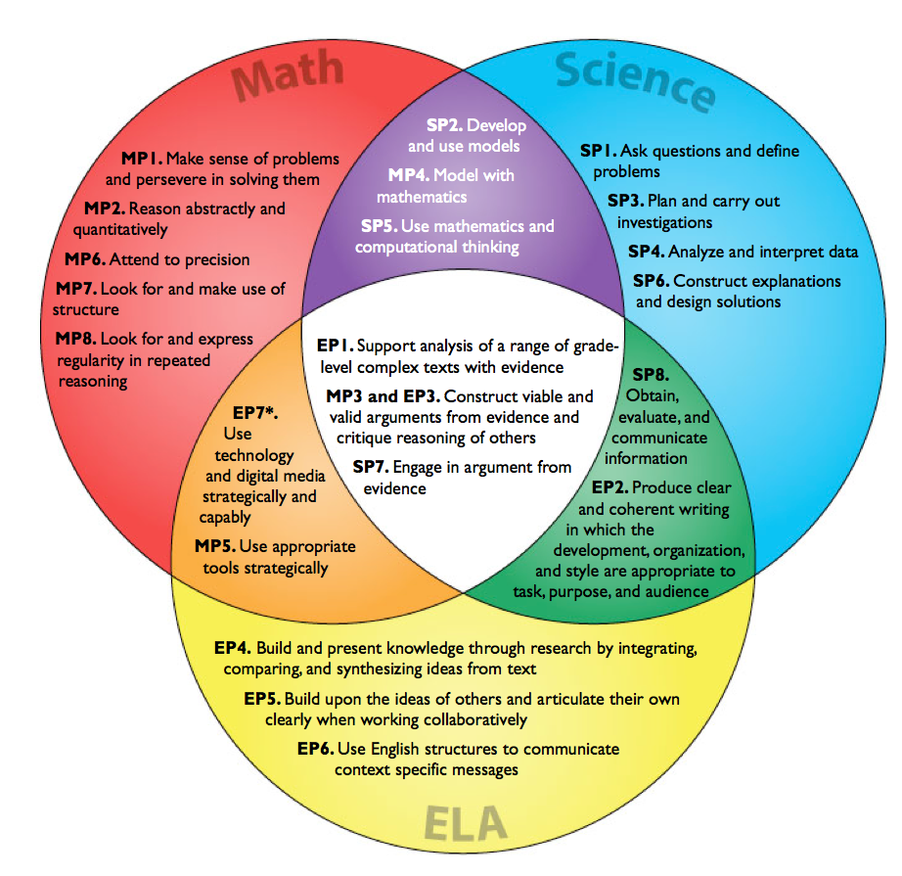
Source: Cheuk 2013.

Learning Relevant to Student Experience and Community Needs
An overarching goal of the CA NGSS is that “all students have some appreciation of the beauty and wonder of science; possess sufficient knowledge of science and engineering to engage in public discussions on related issues;… and have the skills to enter careers of their choice...” (NRC 2012a, 1). Students are more likely to meet this goal when science instruction centers on the interests and needs of students and communities, as well as the contributions of scientists and engineers that reflect California’s diverse population.
Engineering and technology in the CA NGSS. Human society has progressed beyond the time when simply learning about the natural world was a sufficient goal for science education. Today, the scale of our natural resource needs and impacts requires that our citizens be active problem solvers. To accomplish this goal, the CA NGSS require the major shift to explicitly include engineering and technology in the standards and instruction. Scientists and engineers share similar practices but their products are different. The engineering process is “a systematic practice of design to achieve solutions to particular human problems.” (NRC 2012a, 11). Students must engage in this design process at all levels of K–12 instruction. A section at the end of this chapter illustrates the role of engineering and technology in NGSS curriculum.
Explicit focus on Environmental Principles and Concepts. A direct understanding of the connections between humans and the natural world prepares students to address the environmental challenges of today and of the future, to mitigate and prepare for natural hazards, and to interact in a responsible and sustainable manner with the natural systems that support all life. California has identified several critical understandings, called the Environmental Principles and Concepts (EP&Cs; table 1.4), that every student in the state should learn and be able to apply. The State Board of Education (SBE) officially adopted the EP&Cs in 2004 and they are an important piece of the curricular expectations for all California students. Teachers can introduce these EP&Cs through their many connections with the three dimensions of the CA NGSS, and by focusing instruction on the environment of their local community and the issues that it faces.

Table 1.4. California’s Adopted Environmental Principles
Principle I—People Depend on Natural Systems
The continuation and health of individual human lives and of human communities and societies depend on the health of the natural systems that provide essential goods and ecosystem services.
Concept a. The goods produced by natural systems are essential to human life and to the functioning of our economies and cultures.
Concept b. The ecosystem services provided by natural systems are essential to human life and to the functioning of our economies and cultures.
Concept c. The quality, quantity and reliability of the goods and ecosystem services provided by natural systems are directly affected by the health of those systems.
Principle II—People Influence Natural Systems
The long-term functioning and health of terrestrial, freshwater, coastal and marine ecosystems are influenced by their relationships with human society.
Concept a. Direct and indirect changes to natural systems due to the growth of human populations and their consumption rates influence the geographic extent, composition, biological diversity, and viability of natural systems.
Concept b. Methods used to extract, harvest, transport and consume natural resources influence the geographic extent, composition, biological diversity, and viability of natural systems.
Concept c. The expansion and operation of human communities influences the geographic extent, composition, biological diversity, and viability of natural systems.
Concept d. The legal, economic and political systems that govern the use and management of natural systems directly influence the geographic extent, composition, biological diversity, and viability of natural systems.
Principle III—Natural Systems Change in Ways that People Benefit from and Can Influence
Natural systems proceed through cycles that humans depend upon, benefit from, and can alter.
Concept a. Natural systems proceed through cycles and processes that are required for their functioning.
Concept b. Human practices depend upon and benefit from the cycles and processes that operate within natural systems.
Concept c. Human practices can alter the cycles and processes that operate within natural systems.
Principle IV—There are no Permanent or Impermeable Boundaries that Prevent Matter from Flowing Between Systems
The exchange of matter between natural systems and human societies affects the long-term functioning of both.
Concept a. The effects of human activities on natural systems are directly related to the quantities of resources consumed and to the quantity and characteristics of the resulting byproducts.
Concept b. The byproducts of human activity are not readily prevented from entering natural systems and may be beneficial, neutral, or detrimental in their effect.
Concept c. The capacity of natural systems to adjust to human-caused alterations depends on the nature of the system as well as the scope, scale, and duration of the activity and the nature of its byproducts.
Principle V—Decisions Affecting Resources and Natural Systems are Complex and Involve Many Factors
Decisions affecting resources and natural systems are based on a wide range of considerations and decision-making processes.
Concept a. The spectrum of what is considered in making decisions about resources and natural systems and how those factors influence decisions.
Concept b. The process of making decisions about resources and natural systems, and how the assessment of social, economic, political, and environmental factors has changed over time.

Connecting to student experience. California cannot meet the goal of having “all standards for all students” unless it recognizes the rich diversity of background experiences each student brings to the classroom. Students are more likely to remain engaged in science when students: (1) share common experiences through direct investigation of phenomena in the classroom; (2) address science phenomena relevant to their own lives; and (3) receive appropriate support for language and skills development. Practices focused on communicating science are an essential component of the CA NGSS, and shared experiences are an essential entry point that give students “something to talk about” as they develop their language skills. Access and Equity, chapter 10 in this CA Science Framework, and Appendix D of the NGSS describe the types of support that benefit students with different backgrounds and learning needs to ensure that all students have the opportunity for high-quality science learning.

The Three Dimensions in Depth

Dimension 1: Science and Engineering Practices
Scientists and engineers need many skills to answer questions and solve problems. There is no unique or linear scientific method and many of the most important scientific discoveries in history did not follow the process conventionally portrayed in textbooks. Both Darwin’s work on natural selection and Wegener’s work on plate motions never involved testing of a theory-based hypothesis, but both developed a model they thought offered the best explanation of their observational data. The link between smoking and cancer was not established by conducting an experiment – rather it was determined by looking for a pattern in a large data sample. Each scientist follows a different path, but they do draw upon a common set of tools in different sequences. The eight SEPs capture the range of tools used by scientists and engineers.
The NRC Framework (2012a) illustrates the activities of scientists and engineers by an interconnected flow of practices that fall into three general categories: investigating, developing explanations and solutions, and evaluating. Figure 1.5 is a graphical model of how these practices work together. In the investigating panel on the left, scientists observe phenomena in the real world and work on designing experiments, collecting, categorizing, identifying patterns, and analyzing and interpreting their data. In the right panel of scientists develop models about the observed phenomena, developing hypotheses, and constructing explanations, often using mathematics to describe the world and make testable predictions. At the intersection between investigation and developing explanations, scientists and students argue and critique, evaluating the validity and reliability of their data, contrasting their data with their theoretical predictions, and identifying flaws both in their own and others’ ideas.

Figure 1.5. The Scientific and Engineering Enterprise Represented as an Interconnected Flow of Practices within a Social Community
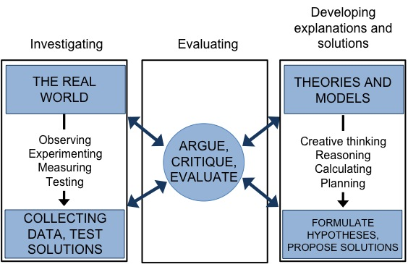
Source: Reprinted with permission from NRC 2012a by the National Academy of Sciences, Courtesy of the National Academies Press, Washington, D.C.

Critique and argument are central to the construction of knowledge (Ford 2008), and evaluating arguments is a critical practice in science because it reveals flaws that prompt scientists to rethink their existing understanding. Indeed, the history of science is a history of uncovering error. Some particularly notable scientific ideas that have been replaced throughout history include:
- Ptolemy’s model of the Earth at the center of the Universe
- Pouchet’s conclusion that rotting food was the product of ‘spontaneous generation
- Lamarck’s conclusion that an animal would pass on acquired or learned traits to its offspring
- Hoyle’s model that the Universe existed in a steady state.

All of these ideas were “scientific” at the time – they were supported by observational evidence (often collected using modern experimental methodology) and self-consistent theories. And yet, each was abandoned and replaced when flaws were discovered in the initial evidence, or when further investigation found new evidence that could only be explained by a different model. Many linear representations of the scientific method include evaluation as a single step near the end of the process, but figure 1.5 illustrates the central importance of critique and argument at every stage of the scientific enterprise.
While all scientists engage in all aspects of figure 1.5 to some degree, individual scientists may focus on certain aspects. For example, some disciplines of science make a large distinction between scientists who specialize in investigations (the left panel) and those who specialize in developing models (the right panel). These two specializations must work together to evaluate one another’s work (central panel) such that the combined sub-communities complete the full process of science. As individual scientists become more specialized, there is greater need for effective communication to facilitate this collaboration.
Engineers engage in most of the same practices as scientists, but they generally work towards solving a particular problem and developing design solutions that address the problem. Like scientists, they employ practices from all parts of figure 1.5. They make observations in the real world (left panel) to define the problem, propose solutions based on creative thinking and planning (right side), and test solutions in the real world (left panel). The competing solutions are evaluated at all stages of the process based upon criteria that provide limits or constraints imposed upon their approach (center panel). Much like scientists, they argue and critique designs, but the end goal is not a refined idea but rather an improved solution.
One of the major instructional shifts of the CA NGSS is to engage students in more elements of the complete scientific enterprise. When teachers examine figure 1.5, they can ask themselves how much time students engage in each of the three panels. To aid that process, writers of the NRC Framework further subdivided the behaviors of scientists and engineers into individual practices. The notion of science as a set of practices has emerged from the work of science historians, philosophers, cognitive scientists, and sociologists over the last few decades (see for example, Passmore, Svoboda, and Giere 2014). The consensus view in the NRC Framework is that there are eight practices common to all the sciences and engineering that are relevant for K–12 education. These practices have been adopted as the SEPs in the CA NGSS (table 1.5).
Table 1.5. CA NGSS Science and Engineering Practices (SEPs)
Science and Engineering Practices
[SEP 1] | Asking Questions and Defining Problems
[SEP 2] | Developing and Using Models
[SEP 3] | Planning and Carrying Out Investigations
[SEP 4] | Analyzing and Interpreting Data
[SEP 5] | Using Mathematics and Computational Thinking
[SEP 6] | Constructing Explanations (for science) and Designing Solutions (for engineering)
[SEP 7] | Engaging in Argument from Evidence
[SEP 8] | Obtaining, Evaluating, and Communicating Information

Each practice develops over the grades following the sequence in appendix 1 of this CA Science Framework.

SEP-1. Asking Questions and Defining Problems
Humans are born curious, and education helps formalize this curiosity about the natural world into the process of science. Despite curiosity’s foundational role in scientific inquiry, many classrooms provide few opportunities for students to express their curiosity by asking questions (Engel 2011). Meanwhile, textbooks are full of explanations but rarely begin by stating the question that led scientists to seek an answer (Ford 2006). Students need the time and curricular space to ask questions, and the CA NGSS encourages this outcome by elevating the act of asking questions to be co-equal to the other practices of science and engineering.
Questions are the engine that drives all scientific research and good research often generates more new questions than answers. Asking questions and defining problems [SEP-1] in the CA NGSS classroom serves two goals that parallel the role of questions in scientific research: (1) to motivate students to explore, create, and innovate; and 2) to guide further investigation and design solutions. While having teachers ask effective questions is a good demonstration, this practice is not fully realized until students can generate their own questions. When students ask questions, they activate their prior knowledge, focus their learning efforts, and elaborate on their knowledge. In short, they begin to drive the science learning process for themselves, pursuing questions that interest them and ensuring that each investigation has personal value.
Expert scientists ask more questions that allow them to better plan and guide their investigations than novice science students (Hackling and Garnett 1992). The CA NGSS describe how students can advance along this developmental progression (Appendix 1 of this CA Science Framework). They begin in kindergarten by asking questions about what they observe and progress by the end of high school to refining empirically testable questions. This transformation occurs partly because students master the CCCs that describe the types of things scientists think about. Each CCC can be related to generic questions that students slowly add to their mental library of templates for productive questions: What patterns [CCC-1] do I see in the data? What are the possible causes [CCC-2]? Did I measure the quantities [CCC-3] precisely enough? How are different components in the system [CCC-4] exchanging energy [CCC-5]? How well matched is this object’s structure to its function [CCC-6]? Are the changes [CCC-7] reversible? For example, as students revisit forces and motion (PS2.A), questions evolve over the years: Why did the car stop? … What force caused [CCC-2] the car to stop? … Where did the car’s energy [CCC-5] go? … How much would the car’s speed change [CCC-7] if I reduced friction by adding oil to the axel?
When defining problems, engineers ask questions to discover the nature of problems, the needs of people, and the constraints that affect how they can solve the problem. For example, a structural engineer might ask about how a building will be used in order to determine how much the structure needs to carry, a bioengineer might ask which materials are more suitable for the design of a prosthetic limb, or an environmental engineer might ask if removing a dam will affect water quality downstream. Throughout the design and testing process, engineers ask further questions about the performance of their solution and how it can be improved.

SEP-2. Developing and Using Models
Models are analogs of objects or processes. They are more than just representations of objects; they must be useful for predicting and explaining phenomemena (table 1.6). Models can be expressed in many different formats ranging from equations to three-dimensional objects.
Models in the CA NGSS almost always refer to models of systems [CCC-4] in that they describe the components of a system and how they interact. The boundaries of the system are evident by what features are included in the model and which are left out. The components can be both concrete aspects (e.g., an object) as well as abstract aspects (e.g., arrows showing the forces on an object). Models are especially useful when systems are especially large (such as the interior of a volcano or the relationship between the Sun, Moon, and Earth), too small to see directly (such as a cell, molecule, or atom), or outside the scope of student observation (such as continental drift and orbits).

Table 1.6. Comparison of Representations and Models
A representation, but not a model | A model that represents a phenomenon
Toy car sitting on a table | Toy car placed in a wind tunnel to model drag between the car and air.
A globe | A spinning globe and a flashlight to show how day and night are related to Earth’s rotation.
A diagram of the cell with parts labeled | A diagram of a cell with parts labeled and arrows indicating how oxygen and other molecules move through the parts of the cell during photosynthesis.

Student-developed models should be continually revised and made more sophisticated over time. Students should be continuously developing and presenting their models, in collaboration with other students, while engaged in the practices of science and engineering. Models help make the thinking of students explicit, and this allows for continual refinement of students’ mental models of how the world works, and the incorporation of new observations and learning over time.
Just as students need to read engaging literature to become better writers, students need to see and dissect examples of models developed by others to become good modelers (see table 1.7). Computer models are well suited for examination because they allow students to visualize processes that they cannot directly observe and quickly perform investigations to try things out – using results to refine their internal mental models. With training in computer languages, students can “look under the hood” to see how computer models were constructed and modify them as their understanding of the real-world system grows.

Table 1.7. Types of Models
Model Type | Description | Example
Mental Models
Mental Models | A model of the way the world works that an individual carries in his or her mind; an internal construct. | 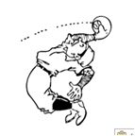  A baseball player moves to catch a ball based on a mental model that predicts how the ball will travel.
Conceptual Models
A mental model that has been made explicit and conscious so it can be shared.
Pictorial models | Diagrams, concept maps, animations, and maps are all techniques for displaying systems visually. | 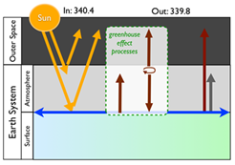  This diagram of Earth’s energy balance uses arrows to indicate the flow of energy between different components of the Earth system.
Physical Models | Physical models can reproduce the structure/shape and/or material properties of objects (as in a clay model of tectonic plates colliding or a scale model of a bridge), or their behavior (as when students act as droplets of water and move around the room as a model for the water cycle). | 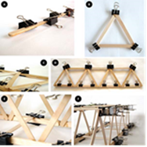  A scale model of a bridge allows students to compare different structural shapes.
Mathematical Models | The variables in an equation represent components of an abstract system and the relationships between the components are expressed by the mathematical symbols. Graphs can also be used as mathematical models because they are essentially the graphical representations of the underlying equations. | F=ma  The equation can be used to predict how quickly an object will change speeds when a force is applied.
Computer Models | Computers enable modeling of systems that contain a large number of components and/or interactions, which are represented by a complicated set of interrelated mathematical equations. | 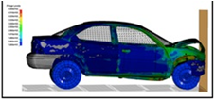  A computer simulation includes all the parts of a car and their material properties. The computer uses equations such as Newton’s laws to calculate the movement of each part during a collision. The color code represents the force per unit area calculated at every point on the car, providing engineers more detail than if they crashed a real car.
Analogies | Analogies help students understand relationships between objects and are therefore models.  Analogies work well at conveying some ideas but can sometimes spawn unintended misconceptions. However, this feature is not unique to analogies: all models are simplifications of complex phenomena and therefore have limitations. | 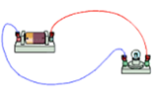  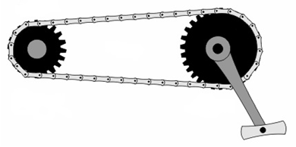  A bicycle chain is an analogy for an electric circuit in that there is an energy source and a load and that it must be connected in order to work.
Image Sources: Clker-Free-Vector-Images 2012, M. d’Alessio, Science Buddies 2015, Livermore Software Technology Corporation 2017, State of Victoria (Department of Education and Training) 2014, British Energy n.d.

Modeling follows a developmental progression. Students start with simple physical and pictorial representations. Even at a young age, students begin to focus on the key features of the object or system of objects that are important for describing a particular phenomenon. They quickly add representations of tangible behaviors like arrows representing the direction of movement or of a push or pull. At higher grades, models become more abstract, multifaceted, dynamic, and reliant on mathematics and computational thinking.
A single phenomenon can be represented by a wide range of conceptual models, as evident from the ideal gas model in chemistry. Students can use the analogy of gases as tiny spheres that collide with one another, transferring energy like billiard balls. Students can use their bodies to represent individual molecules and bounce off one another, which is a simple physical model of the system. Representing these interactions mathematically, scientists can derive a mathematical model that results in the simple equation PV=nRT. A computer model programmed to simulate thousands of gas molecules governed by physical laws provides students with an experimental testbed (test environment with controlled conditions) where students make predictions and investigate what happens when they change the volume of the gas’s container or heat it. By using and modifying computer models, students play the role of theorist and experimentalist, ask questions, and make discoveries that are new to science.
Engineers use models throughout the design process. As they plan design solutions, they make diagrammatic representations of systems, such as blueprints or circuit diagrams. They use three-dimensional scale models and computer simulations to test the properties of a proposed design solution. They employ mathematical models to determine the appropriate materials and even to calculate the likelihood that their design will fail.
Engaging students in modeling not only develops student understanding of the concepts of science, it is also a form of meta-knowledge about the nature of science. When students construct models, they can understand that the goal of science is not to construct a picture that accurately depicts every aspect of nature, but rather a map which captures the most important features that explain the phenomena of interest. They must focus their attention on key aspects of the system and the variables that are relevant to that process, while de-emphasizing details which are less relevant at that moment but may be reconsidered later. Providing opportunities for students to examine, develop, and use models may be a new aspect of science teaching for many teachers. In fact, teachers have been teaching students to use models without always introducing that term. The major shift of the CA NGSS is to move from internal mental models to models that students can share, discuss, critique, and refine (known as conceptual models). Table 1.8 shows more details about how teachers can achieve this big picture shift. As students make their own thinking visible and explicit by developing their own models, they will better understand scientists’ models and the reasons why scientists engage in such practice. Just like scientists, they must revise and adapt their model when they encounter a situation that cannot be explained by applying their existing model. This process of the explicit revision of a model supports the conceptual change needed to incoporate the new knowledge and be able to apply it in new contexts.

Table 1.8. Shifts to Focus the CA NGSS Modeling Practice
More of… | Less of…
Generating models to convey concepts | Pictures to show
Drawing of models to illustrate function | Labeling parts of a diagram to name structures without discussing their function
Simulations with variables that students can manipulate | Demonstrating a process or showing a video of a process without an opportunity to discuss details or investigate and predict behavior
Decoding, understanding, testing, and refining models made by others | Running simulations on models as black boxes without extension or adaptation
Identifying the abstractions, limitations, and assumptions made in models | Using models without attempting to understand the abstractions, limitations, and assumptions made
Using dynamic models that “act like” the system modeled and show change over time | Using static models that only “look like” the system being modeled

SEP-3. Planning and Carrying Out Investigations
Science cannot proceed without direct observations collected through investigations in laboratories, in the field, or on a computer. While many students picture scientists in white lab coats, investigations are not synonymous with experiments. Data can be the product of experiments where scientists set up a specific controlled situation or of direct observations where scientists examine phenomena as they occur within the natural world. Such direct observations are required in many fields such as Earth and space science and life science because it is simply not possible to recreate all the conditions of an ecosystem, a galaxy, or Earth’s history over the last 4.6 billion years. Investigations using computer models are particularly powerful because it is easy to explore a vast number of possible scenarios – rather than setting up a single experiment, computers can calculate hundreds of variations. Students in the CA NGSS classroom should experience all these forms of investigation.
The inclusion of planning investigations represents a shift for many classrooms, but is an essential part of SEP-3. The planning stage is a bridge to the questions that originally motivated students’ inquiry. The questions strongly dictate the type of data collected, how precise the data need to be, how much data to collect, and which tools to use.
As students plan and conduct investigations, they should be able to:
- Collect data, including both quantitative measurements with specific units and qualitative observations.
- Assess and minimize uncertainty by repeating and averaging measurements.
- Apply the concept of variables to design controlled experiments that record the effects of independent variables on dependent variables. Recognize which variables can be fixed or controlled and which cannot.
- Represent data using tables, graphs, and charts.
- Decide whether a question can be tested by an experiment or requires field observations.
- Decide if a computer model will work better than experimentation in the real world (phenomena that are too dangerous, too expensive, too time consuming, etc.).

Another goal of having students engage in investigation and reflect upon their experience is to deepen their understanding of its role in science. To make these connections more powerful, investigations should be rooted in real-world data or experiences and not limited to tabletop experiments.
Engineers also plan and carry out investigations but with a different purpose than scientists. The engineer investigates in order to obtain data and information to define the design problem. For example, before engineers can build a bridge they must investigate the river and the surrounding landscape to determine potential hazards or construction challenges. Engineers might investigate the properties of different materials in order to choose the most appropriate ones for their specific situation. Engineers perform investigations using computer models to rapidly test a variety of possible solutions. Once engineers have created a solution, they perform experiments to test its effectiveness.

SEP-4. Analyzing and Interpreting Data
Observations in nature, experimental inquiry in the laboratory, and running simulations on the computer all produce data. The purpose of science, however, is not to produce data, but to answer questions. Scientists and engineers employ analysis and interpretation to see if their data can answer their questions. While engineers often deal with different types of data than scientists, they share many of the same analysis and interpretation tools.
Data analysis is the process of getting data ready for interpretation. It includes organizing and presenting the data so that patterns are revealed. Interpretation will make meaning of those patterns. The first stage of analysis is to ensure that the data are reliable. Did we make an error collecting the data? Do all the observations reflect the true physical process being investigated? Errors can be random (such as small variations in measurement due to imprecise tools or small variations in the object itself), or systematic (for example a mistake in calibration of a measurement instrument, bugs in the computer code underlying the simulation, or bias in the data made available for others to interpret). A common solution to minimizing error is to collect as many observations as possible and to average them. Calculating averages and other statistical analysis are the next stages of data analysis. The final stage of analysis is presenting the data in a usable form, often as graphs and data tables.
Data interpretation is where scientists begin to get answers to their questions. They recognize trends and patterns in the data and use these to infer cause and effect relationships. Despite all this work, data sets cannot always provide a definitive answer. Insufficient and ambiguous data sets are probably the norm in science rather than the exception, and students need to experience these situations in the classroom so that they do not come away thinking that science is about finding the carefully cultivated “right answer.” The scenario below (figure 1.6) shows students confronting realistic data where multiple interpretations are possible.

Figure 1.6. Investigating Data and Multiple Interpretations
Some students are investigating whether there is a pattern between a person’s pulse rate and the number of breaths they take. The scatter graph for their results is shown below.
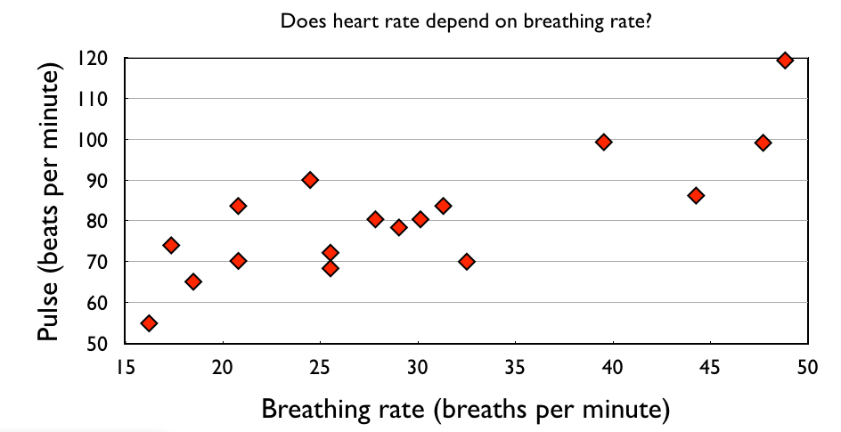
Different students tried to describe the pattern in the graph, each making one of the following statements:
(a) One student had the most breaths and she also had the highest pulse rate.
(b) All the people with a high breath rate had a high pulse rate.
(c) The higher your breathing rate, the greater the pulse rate.
(d) On the whole, people with a higher breath rate had a higher pulse rate.
Which student’s claim is the best interpretation of the data and why?
Source: M. d’Alessio

In the example above, choice a, while correct, does not incorporate the data set as a whole. Choices b, c, and d are all generally correct because they identify the correlation between breath and pulse rates across the entire data set. Choice d is the most appropriate because the qualification “on the whole” acknowledges that the correlation is not 100 percent. This either indicates that there are random measurement errors or that other factors affect heart rate independently from breathing rate. Now students have both a general answer to their original question, but also a new question about what the other factors might be.

SEP-5. Using Mathematical and Computational Thinking
All modern fields of science and engineering are increasingly reliant on mathematical, computational, and statistical techniques. Mathematical thinking includes mathematical deduction, statistical techniques, and spatial thinking. Scientists often rely on statistical techniques to determine the characteristics of a data set, make inferences based on samples, and justify that the relationships they have identified could not have occurred by chance. Mathematical deduction can be used in mathematical models to generate quantitative predictions. The related practice of computational thinking is the human ability to formulate problems so that their solutions can be represented as computational steps or algorithms (Wing 2006). Scientists and engineers use these algorithms when developing computer simulations to represent real-world phenomena. Mathematics and computational thinking are not external to the scientific and engineering enterprise; they are intrinsic to its practice.
Mathematics is a tool for communication that functions as one of the languages of science and engineering. Numerical representation of quantities is the basis of all measurement in science. Representing data numerically and statistically allows students to determine and communicate the level of confidence or uncertainty in a stated result. The symbolic representation of variables allows scientists and engineers to concisely communicate their systems models. Graphical representations are the most common forms of communicating the findings of investigations.
Computational thinking embodies one of the most useful skills in science and engineering: the ability to break a large problem down into smaller pieces. A computer program solves each piece independently. Scientists and engineers benefit from this aspect of computational thinking when they try to describe systems [CCC-5]. They identify individual components of the system (abstraction), determining how the components behave independently, and then designing an architecture that allows the objects to interact. These behaviors can then be encoded in executable computer code (automation of algorithms) and analyzed to determine if the abstractions made were valid and the encoding of algorithms was correct (analysis).
The level of mathematical thinking applied in the science classroom should parallel the learning of new mathematical skills and practices expected by the CA CCSSM. In the primary grades students can calculate the difference between two measurements to find out how much a plant has grown and to make a graph of measurements collected over time to represent that same idea. As students begin to measure various quantities they will need to discuss and use a variety of units of measure. Starting in upper elementary grades, students encounter and discuss quantities in their scientific investigations that involve more than one type of unit of measure, such as speed as distance travelled divided by time taken, or density as mass per unit of volume. Graphical representations of data, and the recognition of linear relationships in the graphs of distance traveled vs. time elapsed for an object moving at a constant speed, or for mass vs. volume for objects made from a given substance, can help students grasp the new concepts. With appropriate support and discussion, the mathematical representation becomes a tool for developing the scientific idea and the scientific idea serves as a motivation for learning the mathematical skill. By high school, students will use and interpret a greater variety of graphical representations, algebraic relationships and basic statistical representations of results.
Computational thinking is likewise developed progressively across the grades as students develop algorithms for automating computation and for describing behaviors of components in computer models. The learning progressions in the CA NGSS (Appendix 1 of this CA Science Framework) do not specify any computational thinking benchmarks for grades K–5. At the middle grade level, students can implement simple algorithms for repeated calculations. For example, students with a data table with columns for the mass and volume of many samples can calculate the density of each sample in a third column. Once they understand that this is a repeated operation, they can either continue to carry it out over and over again or code the calculation algorithm into a spreadsheet or other coding language (e.g., C++, Python, etc.). Middle grade level students should be able to use digital tools to analyze large data sets, which often includes such repeated calculations. Understanding computational processes and how computers are programmed to carry out tasks is also essential in interpreting, using, creating, and modifying computer simulations at the upper secondary level. In high school, modeling and simulation tools (e.g., StarLogo, NetLogo, Agentsheets, etc.) can greatly facilitate the development of models of complex systems. These tools can be introduced using a developmentally appropriate sequence of “Use-Modify-Create.” Students first use pre-existing computer models to run experiments. Over time they begin to modify the models with increasing levels of sophistication. For example, a student may initially want to change the color of a data point in a model result. Later the student may want to change some small aspect of the model’s behavior that requires modifying an algorithm. As students gain skills and confidence, they develop new computational projects of their own design. Within this “create” stage, all three key aspects of computational thinking: abstraction, automation and analysis, come into play.
Mathematics and computational thinking are also essential to engineers. For example, mathematical inequalities can specify design constraints more precisely than words (e.g., “must weigh less than x” instead of “should not be too heavy”). Like systems in science, computers can represent individual objects or components that are pieces of a design solution. Computer tools such as simplified computer-assisted design programs (e.g., Tinkercad, SOLIDWORKS, etc.) or simplified simulation builders (e.g., NetLogo, PowerSim, Scratch, etc.) can greatly facilitate the iterative design process for students at the high school level. The ability to use and code such tools can extend students’ capability to develop design solutions. In earlier grades, students can use simple tools such as drop and drag drawing tools to create visual representations or simple robotics kits where computational thinking allows students to create instructions that allow their robot to achieve specific engineering goals.

SEP-6. Constructing Explanations and Designing Solutions
A key shift in the CA NGSS is that it is not enough for students to know scientific explanations – they must be able to construct them. Students will still learn accepted scientific concepts and terminology, but only as they seek information and words to develop their own models and explanations of phenomena.
A major goal of science is to learn about the way the world works: “Why do we look like our biological parents?” “Why is the sky blue?” or “How did the universe begin?” To answer such questions, scientists develop explanatory accounts of specific phenomena. Explanations describe specific cause and effect [CCC-2] mechanisms that account for observations. Explanations are based on accepted understanding about how the world behaves and are therefore reliant on models. In fact, an ‘explanation’ articulates in words or pictures the specific sequence within a model that explains a phenomenon. A valid explanation must be consistent with all the observations and data. In some cases, several different explanations might exist to explain a given phenomenon. In such cases, scientists engage in the related practice of argumentation [SEP-7] to decide which of the proposed explanations is most accurate.
How do students learn to construct explanations? At the earliest levels, students describe their observations of sequences of events, or “evidence-based accounts of phenomena” (e.g., “first I saw this, then I saw this happen…”). They then associate cause and effect mechanisms with those sequences, using their observations as evidence to justify why they think a particular mechanism is involved. They learn to evaluate explanations for consistency with particular pieces of evidence. By middle grade level and high school, students are able to consider mechanisms that are more abstract (such as atomic interactions) and use more sophisticated data interpretation as the evidence to support explanations. This sequence largely parallels the developmental progression for models because explanations draw so heavily on models. Like models, explanations must be consistently expanded upon and revised as students gain greater understanding. Recognizing the information that is relevant and useful, asking questions, seeking additional information, and assembling scientific facts into a coherent explanation is a demanding task but, nevertheless, the kind of task that students should experience rather than solely being told.
Engineers also use the pratice of constructing explanations, particularly when they are trying to describe why a design solution failed. Examples include engineering disasters such as the collapse of the Tacoma Narrows Bridge in 1940, the Challenger space shuttle disaster of the 1980s, or, more recently, the concerns about the structural integrity of the bolts on the new San Francisco-Oakland Bay Bridge. Each of these failures is a specific set of phenomena that needed to be explained in order to generate a new solution.
Engineering’s main focus is not explanation, but rather proposing solutions to human problems. Examples include how to build a self-driving car, how to provide clean water, or how to generate electricity more efficiently. Unlike in science, there is never one best solution; instead there are multiple solutions that engineers evaluate using criteria different from those used by scientists. Even when a certain engineering design does solve the particular problem, there will still be questions and trade offs about cost, aesthetics, client satisfaction, and safety. Deciding which of several possible designs best satisfies the criteria and constraints may lead engineers to merge features of several of the original designs (the process of design optimization). Because engineering considers both objective and subjective criteria when selecting final designs, different solutions may be genuinely preferred by different individuals. This may be a shift for science teachers who have long stressed the importance of objectivity in science. When science encounters two radically different explanations of a phenomenon, at least one of them must be incorrect (meaning it does not accurately describe what caused a phenomenon), but that is not true in engineering.

SEP-7. Engaging in Argument from Evidence
There is no such thing as scientific proof, and even what are termed “laws” in science are just arguments that are extremely well supported by evidence. Engaging in argument means supporting or refuting a claim using evidence and reasoning. Argument is essential to all aspects of the scientific enterprise illustrated in figure 1.5. Scientists engage in arguments to decide between different experimental designs, alternative models or explanations, or contested interpretations of a data set. When students engage in scientific arguments in the classroom, they experience authentic science practice and develop strong critical thinking skills.
Argument is an essential and shared concept in the CA CCSS ELA/Literacy and the CA NGSS. These subjects share the need to differentiate between a claim (for which one can provide a supporting argument) and an opinion, (which is simply a matter of personal judgment). All subject areas also share similar norms of respectful and inclusive classroom discourse that teachers must establish and support. Subject areas differ, however, in what counts as evidence and the nature of the reasoning used. Students need to explicitly discuss what is common in the structure of argument across all subject areas, but also what is specific to each subject area, particularly in science. Science arguments iteratively build up models, theories, and explanations (figure 1.7). During part of this process, scientists use models as evidence to make predictions about what data will look like (a form of claim). At other times, the model is the claim itself, supported by evidence from the data. These two directions of reasoning connect during data analysis [SEP-4] as scientists compare the claim generated by a model with patterns in the data in order to make a revised claim about a refined model.

Figure 1.7. Relationship Between Data and Models in Scientific Arguments

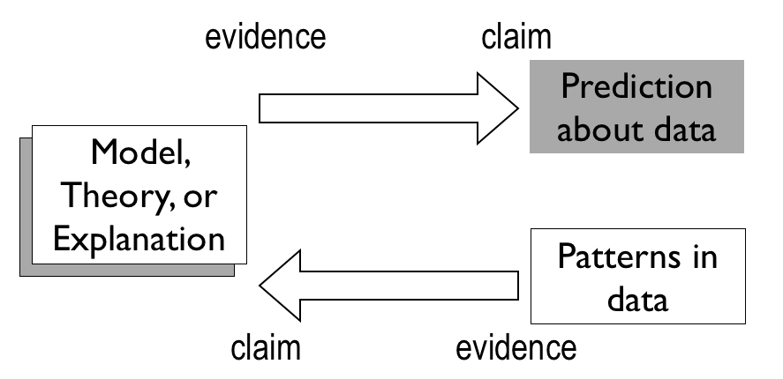
Data and models can both be used as claims and evidence, depending upon which SEPs are employed. Diagram by M. Chiara Simani

Knowing why an idea is wrong is as helpful to learning science as knowing why an answer is right (Osborne 2010). Students recognize both when they engage in argument (Guzetti et al. 1993; Mercer et al. 2004; Zohar and Nemet 2002). Teachers support the argument with effective pedagogy (Ogborn et al. 1996), which includes valuing the process over the outcome. When students support their claims using the available evidence, they sometimes reach conclusions that differ from the scientifically accepted explanation. Teachers can enthusiastically cheer their students for using a reasoned argument and then offer further evidence that refutes the students’ conclusion and develop another that is closer to the accepted scientific one. In all cases, teachers need to set a climate where all conclusions are subject to revision in the light of further evidence. In order to make each revision a learning opportunity rather than a failure, teachers can prompt students to examine the reason for the change rather than simply moving on.
Students develop skill at argument over time. In the early elementary years, students distinguish between opinion and evidence, practice presenting evidence, and recognize when an explanation does and does not account for the available evidence. Students also develop the capacity to listen. As they progress, they develop a more nuanced distinction between facts, reasoned judgment, and speculation. They critique arguments, compare the merits of competing arguments. They learn to anticipate the flaws in their own thinking and develop and refute counterarguments. While they start with arguments about concrete representations of the natural and built environments in elementary school, they construct arguments over increasingly abstract models throughout their education.

SEP-8. Obtaining, Evaluating, and Communicating Information
Science and engineering would be impossible without the foundational literacy skills of reading, writing, speaking, and listening (Norris and Phillips 2003). When asked what a scientist does, the majority of people describe scientists performing experiments, but scientists actually spend a great deal of time reading, writing and talking about ideas (Tenopir and King 2004). Scientists need to be able to communicate clearly with the public to inform public policy. Science and engineering depend on literacy to learn from the work of other scientists, design experiments, and communicate findings. These goals require specific forms of disciplinary literacy for science that students must develop during their science education. Reading a book about a scientist’s life or about a science-related topic is not sufficient for developing literacy in science. While general literacy is the domain of language arts, the specialized communication that supports the other SEPs is best understood when embedded within the context of those other practices in science and engineering lessons. The NRC Framework identifies several ways in which science communication is unique:
- Science and engineering communications are “multimodal” (they use an interconnected mix of words, diagrams, graphs, and mathematics).
- Science and engineering frequently use unfamiliar and specialized words (jargon). A single word, such as “deforestation,” can embody an entire process (including the causes and effects). The NRC (2000, 133) and American Association for the Advancement of Science (1993, 312) strongly discourage the overemphasis on jargon and vocabulary in science education.
- In science and engineering, the details matter. Students therefore need to pay constant attention to every word when obtaining scientific or engineering information.
Students need support to understand and read technical scientific material, whether in a textbook or a magazine article. They also need practice presenting their own ideas using these tools.
Being able to read a science text is intertwined with evaluating science information. Students need strategies to help them decide if information is scientifically valid or if it is less reliable. Students should learn to investigate the scientific qualifications of the authors or source of the knowledge (for example when comparing the conclusions of the International Panel on Climate Change with a blog post or report by a political organization that presents opposing conclusions). Students should also learn to seek and compare multiple sources, asking what evidence each presents to support its claims. Anyone who searches the Web for information about a medical condition will find multiple sources that often give conflicting information. By understanding how science works, students can look for evidence of the other SEPs and are better equipped to evaluate scientific information.
The development of communications skills in science parallels the development of literacy in general. Students obtain information from the simplest informational texts, then learn to summarize them, then compare and combine multiple sources, and eventually integrate a range of sources that include conflicting information. Students engage in multimodal science communication in early elementary informational text by emphasizing the importance of pictures in conveying information. As students progress, they examine how different forms of information complement one another so that by the end of high school, they are able to construct their own scientific accounts that integrate information visually, quantitatively, and in language.

Dimension 2: Crosscutting Concepts
The crosscutting concepts cut across all the disciplines of science and engineering, forging connections that can amplify understanding of the other two dimensions. Even within a single discipline, the CCCs are valuable tools that help students select and use the practices to understand phenomena. In order for them to play these roles, students must be explicitly aware of them and experience them in multiple disciplinary contexts.

Historical Background and Global Context of the CCCs
While explicitly teaching the CCCs is new to California teachers, these concepts have been a part of the science research education community since the early 1990s. Project 2061 defines them as “common themes” (Project 2061 [American Association for the Advancement of Science] 1989, Chapter 11). Analyzing the science standards of ten countries that produce significant scientific innovations and have high scores on international benchmark tests, Achieve (2010) concluded that, "Standards based around unifying ideas for Primary through Lower Secondary seem to confer more benefits than a discipline-based structure." The authors of the NRC Framework recognized the value of highlighting common themes in science when they designed the CCCs:
These concepts should become common and familiar touchstones across the disciplines and grade levels. Explicit reference to the concepts, as well as their emergence in multiple disciplinary contexts, can help students develop a cumulative, coherent, and usable understanding of science and engineering. (NRC 2012a)

CCCs in Brief
The NRC Framework authors distilled the CCCs down to seven ideas with the highest potential of helping students connect science learning across topics (table 1.9). When educators describe these concepts with a common language that bridges across the disciplines, students see how the wide variety of topics that they learn as “science courses” are actually an interconnected web of scientific thinking.

Table 1.9. CA NGSS Crosscutting Concepts
Crosscutting Concepts
[CCC-1] | Patterns | Observed patterns of forms and events guide organization and classification, and they prompt questions about relationships and the factors that influence them.
[CCC-2] | Cause and Effect | Events have causes, sometimes simple, sometimes multifaceted. A major activity of science is investigating and explaining causal relationships and the mechanisms by which they are mediated. Such mechanisms can then be tested across given contexts and used to predict and explain events in new contexts.
[CCC-3] | Scale, Proportion, and Quantity | In considering phenomena, it is critical to recognize what is relevant at different measures of size, time, and energy and to recognize how changes in scale, proportion, or quantity affect a system’s structure or performance.
[CCC-4] | Systems and System Models | Defining the system under study—specifying its boundaries and making explicit a model of that system—provides tools for understanding and testing ideas that are applicable throughout science and engineering.
[CCC-5] | Energy and Matter: Flows, Cycles, and Conservation | Tracking fluxes of energy and matter into, out of, and within systems helps one understand the systems’ possibilities and limitations.
[CCC-6] | Structure and Function | The way in which an object or living thing is shaped and its substructure determine many of its properties and functions.
[CCC-7] | Stability and Change | For natural and built systems alike, conditions of stability and determinants of rates of change or evolution of a system are critical elements of study.

Appendix G of the NGSS describes several guiding principles for integrating the crosscutting concepts into classroom instruction:
- Crosscutting concepts can help students better understand core ideas in science and engineering.
- Crosscutting concepts can help students better understand science and engineering practices.
- Repetition in different contexts will be necessary to build familiarity.
- Crosscutting concepts should grow in complexity and sophistication across the grades.
- Crosscutting concepts can provide a common vocabulary for science and engineering.
- Performance expectations focus on some but not all capabilities associated with a crosscutting concept.
- Crosscutting concepts are for all students.
- Inclusion of the nature of science and engineering concepts.

A coherent curriculum should ensure that every one of the CCCs receives explicit attention and is used often enough that students recognize it and are able to apply it for themselves when presented with a new problem. Waiting until the moment of classroom instruction runs the risk of slipping these important concepts into the background and not allowing students to explicitly use them during problem solving. Hence the design of an Instructional Segment (IS), or an extended curriculum plan should include the intentional and explicit use of particular crosscutting concepts within each IS. In most cases, the relevant CCCs emerge naturally from the other two dimensions. Sometimes CCCs are strongly associated with an SEP. For example, in order to be effective in the practice of developing and using models [SEP-2], teachers must plan instruction so that students draw on their understanding of systems and system models [CCC-3]. Other CCCs tie closely to specific DCIs. For example, PS3.B (Conservation of Energy) is the physical science expression of the flow of energy and matter [CCC-4]. The grade-level chapters in this CA Science Framework investigate phenomena in a sequence of instructional segments that build on earlier science learning. In each IS, a handful of CCCs are most useful for investigating the specific phenomena. Within a grade level, one or two CCCs often recur throughout multiple IS and become a thematic focus for the year. Within every grade span (K–2, 3–5, 6–8, 9–12) all of the crosscutting concepts should be explicitly addressed and each of them should be used in more than one disciplinary context.
The CCCs themselves work together to illustrate a key aspect of the nature of science. Figure 1.8 is one possible illustration of the relationships and interactions between the CCCs. The observation of patterns induces students to search for a mechanism of the cause and effect relationship that underlies those patterns. The crosscutting concept of Structure and Function [CCC-6] can be thought of as a special case of Cause and Effect [CCC-2], this is why it is placed in the “Causality” group. The “system” group contains the crosscutting concepts through which scientists and engineers can gain a better description and definition of the system that they are trying to investigate, including tracking the movement of energy and matter and quantifying them as they change.

Figure 1.8. How Do the Crosscutting Concepts Relate to One Another?
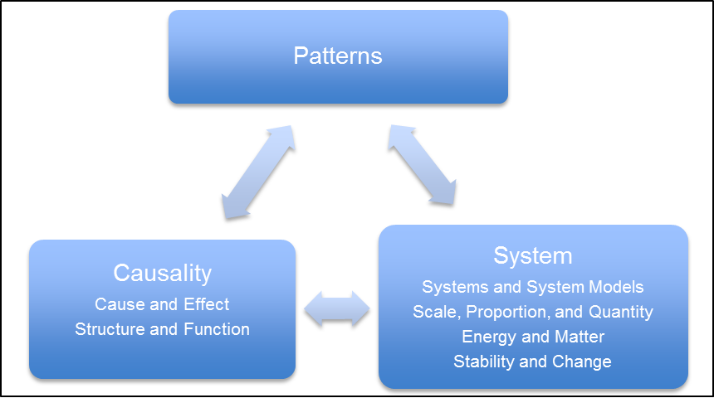
Diagram by M. d’Alessio

Using Crosscutting Concepts through Framing Questions
Each crosscutting concept is a lens that allows students to look at a phenomenon or a problem and ask questions that help them decide how to investigate further. Different CCCs focuses student attention on different aspects of the phenomenon and leads to different questions. For example, reminding students that they should be attentive to the CCC of energy and matter flow [CCC-5] during a chemical reaction should prompt them to ask, “Where did the new solid come from when I mixed together the two liquids?” This question leads them to design an investigation [SEP-3] to measure the mass before and after the chemical reaction. For each crosscutting concept, teachers can formulate a short list of grade-level appropriate questions. Students need to observe these questions repeatedly modeled by the teacher, and eventually, they will systematically use them to investigate, model, and explain on their own. Questions should be mindful of the developmental progression of each CCC (appendix 1 of this CA Science Framework). While the root concept and template for a question may be similar across disciplines, the exact questions may take distinct disciplinary forms. For example, the questions that a biologist asks about relationships between structure and function are very different from those of an engineer. However, both the biologist and the engineer recognize the value of questions about such relationships. The sections below introduce each CCC in detail along with specific questions relevant to each.

CCC-1. Patterns
- What patterns do I notice after careful observation? Do any features emerge from the observations that are interesting or need further study?
- What patterns (repeating cycles, spatial or shape features, relationships between events or features) do I notice in this phenomenon or system?
- What questions do I have about these patterns? (asking questions [SEP-1])
- What features of these patterns can I use to explain my system model(s)? How do I need to modify or extend my model so that it reflects these patterns? (developing and using models [SEP-2])
- What further investigation or observation of the system would help to clarify these patterns and their causes or implications? (planning and carrying out investigations [SEP-3])
- How can I organize and display my observations or data to highlight these patterns or relationships? (analyzing and interpreting data [SEP-4])
- How can I find a mathematical description or computational way to represent these patterns? (using mathematics and computational thinking [SEP-5])
- How can I explain the causes of these patterns, or use the patterns to explain important aspects of the phenomenon or system? (designing solutions [SEP-6])
- What patterns would I like my design to produce in the system? (defining problems [SEP-1] and designing solutions [SEP-6])
- How can I use these patterns as evidence to support my claims or reasoning [SEP-7] about the system or phenomenon?
- What information or tool can I obtain or use to interpret these patterns? How can I best communicate my observations of these patterns to others? (obtaining, evaluating, and communicating information [SEP-8])

As students progress to more advanced levels, they recognize that some patterns are just random occurrences in a complex system. They will eventually need to develop statistical tools to determine how much they can trust the significance of a particular pattern.

CCC-2. Cause and Effect: Mechanism and Explanation
- What relationships between events or what patterns in my observations might be described as a cause-and-effect relationship? (Interpreting data [SEP-4])
- Which features of these relationships would I like to explain [SEP-6]?
- To what extent can my model [SEP-2] provide a mechanism (a physical connection or process) to explain the relationship? What features does it fail to explain?
- How can I design [SEP-6] the system to cause the desired effect?

It is not always possible to determine which is the cause and which is the effect at the level of precision and scale at which the system is currently being observed. By high school, students should recognize that not all correlations signify a cause-effect relationship. A strong correlation does imply that the conditions or events are related, but they might be the effects or outcomes of a different single causative factor.
This idea is illuminated on a massive scale by the historical medical example in which several studies of post-menopausal women who were undergoing hormone replacement therapy showed a lower-than-average incidence of coronary heart disease. This led doctors to suggest hormone therapy as a protective mechanism against coronary problems and millions of women began using the treatment. However, a subsequent re-analysis of data, which expanded the range of variables involved in the studies, found that the women in the studies undergoing hormone treatment were also more likely to have a better diet and exercise regimens because of their socio-economic status. In other words, socio-economic factors were the root cause of both the use of hormone treatment and the diet and exercise patterns (Lawlor, Smith, and Ebrahim 2004).
In high school, students begin to study complex multi-component systems, where feedback complicate the simple idea of cause and effect relationships. It is not possible to directly predict the outcomes of a particular action or set of conditions within these systems. Computer models can allow scientists to provide statistical estimates of the probability of events by testing out a wide range of possible conditions. Examples of these processes include weather forecasting, climate models, and earthquake hazard estimation.

CCC-3. Scale, Proportion, and Quantity
- What aspects of this system do we need to measure or quantify in order to describe it more precisely? (planning investigations [SEP-3])
- On what scale (i.e., with what units and to what precision) do we need to measure it? (planning investigations [SEP-3])
- What do we need to control about the observed system as we make these observations or measurements? (planning investigations [SEP-3])
- What relationships between measurable quantities or between controlled conditions and measured quantities do we observe? (In elementary grades these begin as descriptive, by high school they include algebraic or geometric relationships [SEP-5].) (analyzing and interpreting data [SEP-4])
- How can I use a scale model to test my design? (designing solutions [SEP-6])
- What ratio of model to final system is reasonable to build?
- In calculating costs of materials, how do the amounts of the various materials needed change as I change the length scale of the model or final designed object? (designing solutions [SEP-6])

This CCC has three related sub-ideas. The concept of quantity is fundamentally related to measuring and quantifying phenomena. Each measurement requires a unit of measure. Proportions can relate to patterns [CCC-1] (i.e., “as the mass of the box increases, its force also increases by the same amount”) and are a key tool in mathematical models [SEP-2]. While the term scale can be used similarly to proportion (as in, “scale model” or “map scale”), it also has another, less familiar meaning. Scale in science is a way of expressing the relative size of something at the level of orders of magnitude and is often used to refer to the size of a system (as in the “vast scale of the Universe” or the “micro-scale of a cell”). Certain processes are important at one scale but can safely be ignored at another. For example, students calculating friction do not need to track the interactions of individual molecules of wood as a block slides across a table. They are interested in the overall effect at a larger scale. Similarly, scientists do not need to track the movement of every individual ant to understand the overall flow of matter in an ecosystem. While the micro scale is part of the overall process in both cases, the scale of observation is not precise enough to notice the finer details.

CCC-4. Systems and System Models
- What system or systems do we need to model [SEP-2] in order to explain this phenomenon (develop this design)?
- What scale(s) within the system do we need these models [SEP-2] to describe and represent?
- How can we best choose to delineate the boundary of this system (what is included, what is external)? (developing models [SEP-2])
- What are the components or sub-systems of this system? (developing models [SEP-2])
- What are the roles of each component type, and the relationships and interactions between them? (developing models [SEP-2])
- What are the constraints that my designed system must satisfy? (defining problems [SEP-1])
- Is the system simple enough to be described in detail at the scale of interest or does it have so many components (e.g., atoms in the atmosphere) that only some general average properties can be specified? (constructing explanations [SEP-6])
- How do the properties of the whole system emerge from the behavior of its components, and how do they depend on external conditions? (developing models [SEP-2])
- What does the system tell us about the level of predictability of changes in the system or its details? (For example we can predict the general shape of any species of tree, and of its leaves, but not where each branch and leaf will form, why?) (developing models [SEP-2])

Everything in the Universe is ultimately connected to everything else, so the concept of a system can be very useful for mentally carving out a small piece of that Universe for detailed investigation. By definition, a system has boundaries and the parts contained within those boundaries are called components and they interact with one another. Energy and matter can flow into and out of the system. When students develop models [SEP-2], they are making some sort of representation of the system that predicts the behavior both of the internal components, and the way the system as a whole behaves. In many cases, the overall behavior of the system is quite different depending on the way the system is put together. For example, a bicycle is a great transportation tool, but would be useless if you disassemble it and rearrange the pieces in a different order so that the wheels attach to the seat instead of the axel.
Early grades can consider systems made of specific physical objects such as a car, a bicycle, or an animal. The choice of the boundary of these simple systems is relatively obvious, but it needs to be discussed in order to highlight flows of matter or of energy into and out of the system. Even in these simple systems, the boundary of the system is somewhat arbitrary. For instance, is it most useful to define the system involving a bicycle as the bicycle alone, or the bicycle plus the person riding it? The answer may depend upon the scientific question being investigated. These are the types of questions students need to engage with early on by explicit discussions of systems. Simply being given a definition of a system as a “set of interacting components or parts” does not help to develop this concept. Instead, students must model multiple systems to explain multiple phenomena.
Students should be able to articulate both the uses and limitations of system models, especially those for systems with many components. Models for simple mechanical systems with few components can be very predictive, but chemistry, life science, and Earth science deal with systems that are much more complex. In these cases, models can help us understand and predict general features of what will occur, but does not provide all of the details. Even if the components are all relatively simple, (e.g., the atoms and molecules in the atmosphere) the system can have many properties and exhibit collective phenomena that are not predictable in detail. We cannot know enough about the conditions of the system at any moment to make reliable predictions for its behavior, except possibly for a limited time in the future, and even then we need very detailed and sophisticated computational models. The further forward in time we project, the wider the range of possible outcomes. For example, when predicting the path of a storm we can use its past history and current position as well as knowledge of the surfaces it will pass over and their current conditions (e.g., ocean temperatures) to make reliable estimates of where it will be and how severe it will be the next day. But as we look further ahead, these estimates become less and less definite.

CCC-5. Energy and Matter: Flows, Cycles, and Conservation
- What matter flows into, out of, and within the system? What physical and chemical changes occur during this phenomenon? (developing models [SEP-2])
- What energy transfers occur into, out of, or within the system? What transformations of energy are important to its operation? (developing models [SEP-2])
- What are the needed inputs for the system to function? What are the desired outputs of the system? (defining problems [SEP-1])

Matter cannot just disappear, so we say that it is conserved. The same is true with the less tangible concept of energy. When matter or energy flows from one object to another, it causes changes. Encouraging students to track the flow of these quantities makes them more attentive to these changes and the mechanisms that cause them. Even at the elementary level, students can track matter flowing into and out of systems (e.g., Where does the system get the material it needs to function? What waste material does it produce?). As students progress, their tracking can be more precise and quantitative and they can track the flow of energy and matter through increasingly complex chains.
Energy is described quite differently in different sub-disciplines of science. For students to see energy as a crosscutting concept, they need to explicitly discuss these differences and the reasons they exist. A biology teacher might say that food contains energy. A chemistry teacher might be more specific by saying that a fuel itself doesn’t contain energy, but a combustion reaction releases energy when fuel reacts with oxygen. The difference comes because there is usually plenty of oxygen available in ecosystems and so the biologist can often ignore that part of the flow of matter. However, it is difficult for students to connect the biologist’s usage to definitions of energy in chemistry or to connect energy terms used in chemistry (e.g., bond energy) to those used in physics (e.g., kinetic energy, potential energy, thermal energy) without the teachers helping them to do so by discussing the connections and translations between these usages and terminologies.

CCC-6. Structure and Function
- What particular shapes or structures are observed in this system at this scale? (planning and conducting investigations [SEP-3])
- What roles do these structures play in the functioning of the system? (developing models [SEP-2])
- What differences in conditions relate to patterns of differences in structure or appearance? (analyzing data [SEP-4])
- What design features of appearance and structure are desired by the user of this system? (defining problems [SEP-1])
- What structures and properties of the components are important for the function of this design? (solving problems [SEP-6])

The term “structure and function” may be familiar to teachers from biology textbooks, but the concept that there is a relationship between the shape or form of an object and the behavior of that object applies to all disciplines of science and engineering. In chemistry, the shape of molecules has a huge impact on their attractions to other molecules. In Earth science, the shapes of layers in sedimentary rocks record the physical processes that transported the material and the tectonic forces that deformed it. In physics, longer levers provide more leverage. Mechanical engineering is devoted to arranging materials into shapes that perform certain functions. When students construct models of the relationships between structure and function in one field, they can often apply them to another. For example, when a car’s hood buckles during a crash, it creates similar structures to those created when a mountain deforms during continental collision (figure 1.9). When students recognize this similar structure/function relationship, they can apply the strategies and equations to understand both systems. In fact, mechanical engineers and earth scientists use the same exact computer codes to solve problems in both systems. Mechanical engineers might even get ideas for making better bumpers by observing the deformation in mountains!

Figure 1.9. Similar Structure/Function Relationships in Earth Science and Engineering
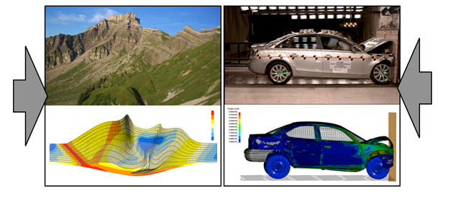
Cinedoku Vorarlberg 2009; National Highway Traffic Safety Association 2016; Willett 1999; Livermore Software Technology Corporation 2017

A relationship between structure and function is often a clue that there is a causal relationship between the two. But which way does the mechanism go? Does structure cause/enable function, or do functions/processes cause certain structures? The answer is complicated and depends on the phenomena and discipline. An engineer designs a car hood with a specific structure so that it will absorb energy in a crash (the desired function caused the design of the structure), but once the hood begins to crumple, the forces within the system change (the structure affects the processes/function). The same is true in biology where a particular shape of a bird beak is well suited to a function of picking up seeds (structure enables function), but the function of eating more may lead to further changes in the beak shape over many generations by the mechanisms of natural selection (structure enables function which leads to changes in structure again). While this feedback is the result of intentional human design for a specific purpose in engineering, the structure/function relationships in other disciplines are the direct outcome of natural processes. Students begin their developmental progression by focusing on just one tangible piece of the cause and effect feedback, such as noticing how a particular bird beak shape helps the bird meet its needs. Students expand their model of these mechanisms over the years to include the feedbacks.

CCC-7. Stability and Change
- What changes do I notice? How quickly is the change happening? (analyzing data [SEP-4])
- What can I investigate [SEP-3] more closely to recognize the cause of a change?
- What flows of energy and matter allow this system to operate stably or cause it to change? (developing models [SEP-2])
- What changes in conditions would cause it to become unstable or to fail? (developing models [SEP-2])
- What feedback loops keep this system stable? What feedback loops destabilize it? (developing models [SEP-2])
- How can I improve the stability of my design? (designing solutions [SEP-6])

Thinkers from Aristotle to Newton have been obsessed over what causes things to change. Newton’s Law that an object in motion will stay in motion unless an unbalanced force acts upon it is a mathematical way of expressing the idea that changes always have a cause. This CCC reminds students to be attentive to changes and ask questions about what causes them.
The concept of stability is related, but invites students to look more closely even at systems that appear to be unchanging. A lake whose water level remains flat and unchanging might be fed and drained by rivers so that the water that makes up the lake is always changing. The lake is stable, but not static – an important distinction emphasized by this CCC. For a ladder leaning on a wall the two concepts may be the same, but for many systems like the lake, stability can be a more dynamic concept. The Moon’s orbit is stable because it happens in a consistent cycle and is not visibly falling down, but the Moon is certainly not static. Stability is always a balance between competing forces – the inflow and outflow of water in the lake or gravity and inertia that keep the Moon in orbit. Things that appear static on one time scale might change when viewed over a longer period because their balance changes. The lake level that appears constant over a day might change with the seasons as rain falls or evaporation dries it up. Even the Moon’s orbit is slowly decaying.
Students in elementary school start by characterizing simple changes, noticing that some systems appear to stay the same, some appear to change slowly, and some appear to change quickly. By the middle grades, they begin to investigate phenomena that are stable but not static and must confront this difference. By high school, explicit teaching of this CCC reminds students to be attentive to minor changes that can have big effects in systems that are in a delicate balance of stability (or dynamic equilibrium). They learn to recognize feedback mechanisms that play a large role in keeping systems stable or rapidly destabilizing them.

Dimension 3: Disciplinary Core Ideas
Disciplinary Core Ideas are not facts, but represent foundational knowledge that allow students to continue their scientific learning beyond high school and to use the scientific ideas to evaluate information and make informed decisions. The NRC Framework describes the motivation for identifying DCIs by saying:
The core ideas also can provide an organizational structure for the acquisition of new knowledge. Understanding the core ideas and engaging in the scientific and engineering practices helps to prepare students for broader understanding, and deeper levels of scientific and engineering investigation, later on—in high school, college, and beyond. One rationale for organizing content around core ideas comes from studies comparing experts and novices in any field. Experts understand the core principles and theoretical constructs of their field, and they use them to make sense of new information or tackle novel problems. Novices, in contrast, tend to hold disconnected and even contradictory bits of knowledge as isolated facts and struggle to find a way to organize and integrate them. The assumption, then, is that helping students learn the core ideas through engaging in scientific and engineering practices will enable them to become less like novices and more like experts. (NRC 2012a)

The writers of the NRC Framework limited the number of core ideas based on the reasoning that in-depth application of the SEPs and CCCs to fewer DCIs is better preparation for future science success than broad and superficial exposure to more DCIs. The number of these core ideas was further reduced during the final development of the NGSS performance expectations (PEs) based on feedback from leading states (NGSS Lead States 2013b). Each of the DCIs included in the CA NGSS meet at least two of these criteria:
- Has broad importance across multiple science or engineering disciplines or be a key organizing principle of a single discipline.
- Provides a key tool for understanding or investigating more complex ideas and solving problems.
- Relates to the interests and life experiences of students or be connected to societal or personal concerns that require scientific or technological knowledge.
- Is developmentally appropriate over multiple grades at increasing levels of depth and sophistication. That is, the idea can be made accessible to younger students but is broad enough to sustain continued investigation over years.

DCIs are organized into four major domains: Physical Sciences; Life Sciences; Earth and Space Sciences; and Engineering, Technology, and Application of Science. Each domain contains three to four disciplinary core ideas, which are further subdivided into core component ideas (table 1.10). The NRC Framework describes each DCI in detail.
Table 1.10. Disciplinary Core Ideas of CA NGSS
Disciplinary Core Ideas in  Physical Science | Disciplinary Core Ideas in  Life Science | Disciplinary Core Ideas in  Earth & Space Science | Disciplinary Core Ideas in  Engineering, Technology, and Applications of Science
PS1: Matter and Interactions  PS1.A: Structure and Properties of Matter  PS1.B: Chemical Reactions  PS1.C: Nuclear Processes  PS2: Motion and Stability: Forces and Interactions  PS2.A: Forces and Motion  PS2.B: Types and Interactions  PS3: Energy  PS3: Energy  PS3.A: Definitions of Energy  PS3.B: Conservation of Energy and Energy Transfer  PS3.C: Relationship Between Energy and Forces  PS3.D: Energy in Chemical Processes  PS4: Waves and Their Applications in Technologies for Information Transfer  PS4.A: Wave Properties  PS4.B: Electromagnetic Radiation  PS4.C: Information Technologies and Instrumentation | LS1: From Molecules to Organisms: Structures and Processes  LS1.A: Structure and Function  LS1.B: Growth and Development  LS1.C: Organization for Matter and Energy Flow in Organisms  LS2: Ecosystems: Interactions, Energy, and Dynamics  LS2.A: Interdependent Relationships in Ecosystems  LS2.C: Ecosystem Dynamics, Functioning, and Resilience  LS2.D: Social Interactions and Group Behavior  LS3: Heredity: Inheritance and Variation of Traits  LS3.A: Inheritance of Traits  LS3.B: Variation of Traits  LS4: Biological Evolution: Unity and Diversity  LS4.A: Evidence of Common Ancestry and Diversity  LS4.B: Natural Selection  LS4.C: Adaptation  LS4.D: Biodiversity and Humans | ESS1: Earth's Place in the Universe  ESS1.A: The Universe and Its Stars  ESS1.B: Earth and the Solar System  ESS1.C: The History of Planet Earth  ESS2: Earth's Systems  ESS2.A: Earth's Materials and Systems  ESS2.B: Plate Tectonics and Large-Scale System Interactions  ESS2.C: The Roles of Water in Earth's Surface Processes  ESS2.D: Weather and Climate  ESS2.E: Biogeology  ESS3: Earth and Human Activity  ESS3.A: Natural Resources  ESS3.B: Natural Hazards  ESS3.C: Human Impacts on Earth Systems  ESS3.D: Global Climate Change | ETS1: Engineering Design  ETS1.A: Defining and Delimiting Engineering Problems  ETS1.B: Developing Possible Solutions  ETS1.C: Optimizing the Design Solution  ETS2: Links Among Engineering, Technology, Science, and Society  ETS2.A: Interdependence of Science, Engineering, and Technology  ETS2.B: Influence of Engineering, Technology, and Science on Society and the Natural World

Students revisit each DCI multiple times as they advance through the grades, building their knowledge in a developmental progression. The NRC Framework provides guidance about the level of understanding that students should acquire by the end of grades two, five, eight, and twelve.
Table 1.2 from earlier in this chapter describes the general pattern of these progressions from concrete to abstract. These learning progressions reflect research-based cognitive models of how learning of scientific ideas unfolds over time. In the earlier grades, the DCIs are limited to only a few contexts and are simplistic in their application. As students progress, they examine more abstract phenomena with more complex applications of the DCIs.
Figure 1.10 shows the progressions for three example DCIs: PS2.B (Types of Interactions), ESS1.C (The history of planet Earth), and LS1.A (Structure and function of organisms). Appendix 1 of this CA Science Framework includes more detailed versions of all the progressions.

Figure 1.10. Examples of Progressions in the Disciplinary Core Ideas
Increasing Sophistication of Student Thinking
 | K-2 | 3-5 | 6-8 | 9-12
PS1.A Structure of matter (includes PS1.C Nuclear Processes) | Matter exists as different substances that have observable different properties. Different properties are suited to different purposes. Objects can be built up from smaller parts. | Because matter exists as particles that are too small to see, matter is always conserved even if it seems to disappear. Measurements of a variety of observable properties can be used to identify particular materials. | The fact that matter is composed of atoms and molecules can be used to explain the properties of substances, diversity of materials, states of matter, phase changes, and conservation of matter. | The sub-atomic structural model and interactions between electric charges at the atomic scale can be used to explain the structure and interactions of matter, including chemical reactions and nuclear processes. Repeating patterns of the periodic table reflect patterns of outer electrons. A stable molecule has less energy than the same set of atoms separated; one must provide at least this energy to take the molecule apart.
ESS1.C The history of planet Earth | Some events on Earth happen very quickly; others can occur very slowly. | Certain features on Earth can be used to order events that have occurred in a landscape. | Rock strata and the fossil record can be used as evidence to organize the relative occurrence of major historical events in Earth’s history | The rock record resulting from tectonic and other geoscience processes as well as objects from the solar system can provide evidence of Earth’s early history and the relative ages of major geologic formations.
LS1.A Structure and function | All organisms have external parts that they use to perform daily functions. | Organisms have both internal and external macroscopic structures that allow for growth, survival, behavior, and reproduction. | All living things are made up of cells. In organisms, cells work together to form tissues and organs that are specialized for particular body functions. | Systems of specialized cells within organisms help perform essential functions of life. Any one system in an organism is made up of numerous parts. Feedback mechanisms maintain an organism’s internal conditions within certain limits and mediate behaviors.
Source: Reprinted with permission from NRC 2012a by the National Academy of Sciences, Courtesy of the National Academies Press, Washington, D.C.
Beyond the Three Dimensions
While the three dimensions are a major part of the CA NGSS, the standards are based on principles that go beyond these three dimensions. Teachers must be mindful of these other considerations, including principles of environmental literacy, engineering design, the nature of science, the language demands in the CA NGSS, mathematical and computational thinking, twenty-first century skills, and integrating science with California’s other standards. This section discusses each of these topics.

Environmental Principles and Concepts
Broadly defined, the “environment” is the context in which we live our lives. It includes high-mountain meadows and cool, clear streams, the air we breathe, the water we drink, and the soils in which we grow the food we eat. The environment also encompasses the communities in which we live and all of the seen and unseen phenomena that comprise the natural systems on which we rely. In this sense, the environment is fundamental to every student’s experience and provides a uniquely engaging and authentic context in which to approach science learning.
For many decades, California has been a national leader in educating students about the environment, and now more than ever, the state recognizes that environmental literacy is crucial to sustaining the economic and environmental well-being of all Californians. This is embodied in the California Education Code and reflected in the educational mandates of many state agencies. Environmental literacy means more than knowing environmental content; it also encompasses civic engagement and community involvement in diverse settings. Going beyond the walls of the classroom, environmental literacy can be developed through investigations on campus, in the local community, on the schoolyard, at nature centers and outdoor schools, as well as in the rich and diverse natural landscapes found throughout California.
Environmental literacy is championed by the California Department of Education, the California Environmental Protection Agency, and the California Natural Resources Agency. It is also fully embraced in a 2015 report prepared by a task force of the State Superintendent of Public Instruction, A Blueprint for Environmental Literacy: Educating Every Student in, about, and for the Environment. Strongly reinforcing the goal of environmental literacy for all kindergarten through twelfth grade students, the blueprint also advocates that all teachers have the opportunity to use the environment as a relevant and engaging context for teaching their core subjects, especially in science and history–social science.
To help fulfill this goal, the California State Board of Education (SBE) approved a framework guideline that calls for the Environmental Principles and Concepts (EP&Cs) to be incorporated into relevant subject matter frameworks, including science. California developed the EP&Cs in 2004 to reflect the fact that people, as well as their cultures and societies, depend on Earth’s natural systems (see table 1.4 earlier in this chapter). The underlying goal of this work was to help students understand the connections between people and the natural world so that they can better assess the consequences of human activity. Every Californian needs to be ready to address the environmental challenges of today and the future, take steps to reduce the impacts of natural and anthropogenic (human-made) hazards, and act in a responsible and sustainable manner. As a result, the EP&Cs have become an important piece of the curricular expectations for all California students in science and other content areas.
Science, at its core, involves study of the living and nonliving components of Earth’s natural systems, including the interactions among organisms, natural systems, climate, and nonliving resources. These interactions are the driving force behind the survival and evolution of all living things. With the world as their laboratory, students have a chance to do authentic scientific research analyzing interactions between natural and human social systems… Additionally, teachers at all grade levels can use the environment as a context for, … vibrant, living programs that engage students and teachers in active learning that has meaning for their daily lives and for their futures. (Lieberman 2013 40, 202)

The EP&Cs provide a meaningful way to teach and amplify many of the ideas that are already embedded in the CA NGSS. Appendix 2 of this CA Science Framework presents diverse examples of the connections that can be made between the EP&Cs and instruction in the three dimensions of the CA NGSS. Table 1.11 shows two examples of this relationship.

Table 1.11. Examples of Instructional Connections Between the EP&Cs and the CA NGSS
EP&C | CA NGSS
Principle I  The continuation and health of individual human lives and of human communities and societies depend on the health of the natural systems that provide essential goods and ecosystem services. | LS4.D: Biodiversity and Humans—“Changes in biodiversity can influence humans’ resources, such as food, energy, and medicines, as well as ecosystem services that humans rely on—for example, water purification and recycling.”
Principle V  Decisions affecting resources and natural systems are based on a wide range of considerations and decision-making processes. | ETS1.B Developing Possible Solutions— “When evaluating solutions it is important to take into account a range of constraints including cost, safety, reliability and aesthetics and to consider social, cultural and environmental impacts.”

In addition to the EP&Cs, the SBE also adopted 40 model curriculum units developed by California’s Education and the Environment Initiative (EEI) that provide guidance about how to teach the EP&Cs. These units are freely available at http://californiaeei.org/framework/sci/EPC and can be used effectively to support three-dimensional learning.

The Role of Engineering Design, Technology, and Application of Science
Engineering is a fundamental part of the CA NGSS from kindergarten through grade twelve. It is both an independent domain with its own DCIs as well as a complement to the other domains of science (table 1.12). Engineering also engages students with major societal and environmental challenges they will face in the decades ahead and gives them tools to design solutions to these problems.

Table 1.12. Disciplinary Core Ideas in Engineering
Disciplinary Core Ideas in Engineering
Core Idea ETS1: Engineering Design
ETS1.A: Defining and Delimiting an Engineering Problem
ETS1.B: Developing Possible Solutions
ETS1.C: Optimizing the Design Solution
Core Idea ETS2: Links Among Engineering, Technology, Science, and Society
ETS2.A: Interdependence of Science, Engineering, and Technology
ETS2.B: Influence of Engineering, Technology, and Science on Society and the Natural World

The Engineering Design Process (ETS1)
The ETS1 core ideas in engineering describe the principles of the engineering design process (figure 1.11). While there are many ways to describe the process that engineers use to solve problems, the three sub-ideas within ETS1 relate to three stages of the iterative design process: Defining and Delimiting an Engineering Problem (ETS1.A), Developing Solutions (ETS1.B), and Optimizing the Design Solution (ETS1.C). While there is an obvious correlation for ETS1.A with Defining Problems [SEP-1] and ETS1.B with Designing Solutions [SEP-6], students should use a variety of practices within this iterative design process. For example, structural engineers need to obtain information [SEP-8] about the size of earthquakes in a region in order to determine the necessary strength of an earthquake resistant structure (Defining and Delimiting the Engineering Problem, ETS1.A).

Figure 1.11. The Engineering Design Process (ETS1)

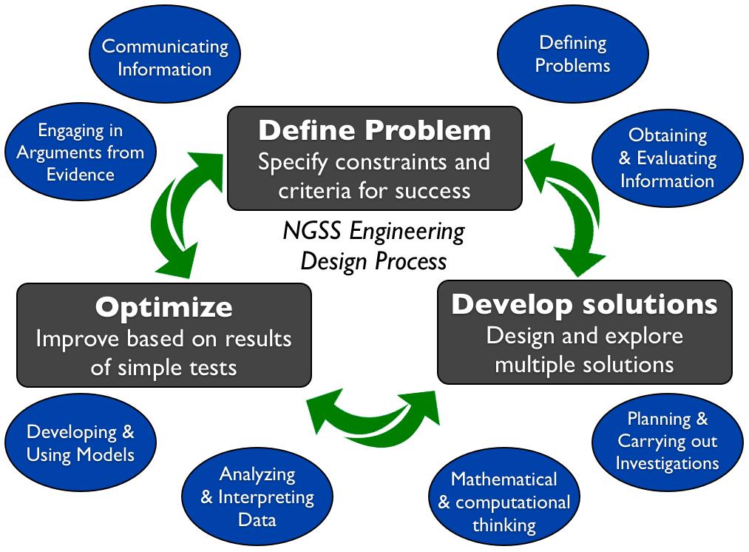
Engineering design is one way to utilize the SEPs. The ovals around the boxes indicate when each SEP might be the emphasis during engineering design. Diagram by M. d’Alessio

Role of Engineering in Science and Society (ETS2)
Engineering is not just applied science. It is a separate endeavor that applies scientific knowledge to design and implement solutions to real-world problems or needs. The practices of engineering have much in common with the practices of science even though they work towards different outcomes: explanations in science and solutions to problems in engineering. An engineering investigation might compare the performance of two design solutions while a science investigation seeks evidence of underlying mechanisms that cause phenomena. The engineering investigation can stop when the engineer has enough information to take a specific action while science investigations can and should lead to new, more detailed questions that require further investigation.
Engineering, science, and technology are mutually supportive (ETS2.A). The NRC Framework highlights this interdependence by saying:
New technologies expand the reach of science, allowing the study of realms previously inaccessible to investigation; scientists depend on the work of engineers to produce the instruments and computational tools they need to conduct research. Engineers in turn depend on the work of scientists to understand how different technologies work so they can be improved; scientific discoveries are exploited to create new technologies in the first place. (NRC 2012a, 203)

Examples of these feedbacks occur throughout the history of science and continue today. For example, the technological tool of the telescope grew out of the science of optics, and then Galileo used the newly-invented telescope to discover the moons of Jupiter.
One of the products of engineering is new technology. Many people have a misconception that technology refers only to electronic devices such as computers and cellphones. While these are indeed technologies, the term technology describes all of the ways that people have modified the natural world to meet their needs. A metal plow or even a pencil is as much a technology as the newest electronic gadget. All technology, new and old, has the capacity to transform human capabilities and experiences. ETS2.B emphasizes the importance of engineering to real-world problems and can be a major motivating factor for students.

When to Include Engineering in the Curriculum
Engineering is part of the performance expectations of the CA NGSS in two ways. A portion of the PEs within the traditional science disciplines (LS, ESS, PS) require students to apply engineering design to solve problems related to those disciplines. These PEs are marked with an asterisk (*) throughout the CA NGSS documents and this CA Science Framework. The limited number of PEs with asterisks should not restrict teachers from including engineering at other appropriate times. In fact, the PEs in the ETS domain apply to each grade span rather than to each grade level because they are designed to supplement both the PEs with the asterisks and other engineering activities that teachers integrate into their instruction.
Appendices I and J of the NGSS provide a more comprehensive review and summary of the progression for the engineering design core idea (ETS1) and the links among engineering, technology, science, and society, core idea (ETS2), respectively.

Language Demands in a Three-Dimensional Learning Environment
In the science classroom, every student is learning new academic language; attention to issues of language development is critical for all students, not just for English learners (ELs). The language demands are far broader than just definitions of vocabulary or reading about science-related topics. These interpretive language tasks alone do not support linguistically diverse students. Teachers should also provide students ongoing opportunities to engage in scientific discourse. In the CA NGSS, language and literacy skills are necessary for students to engage in the science and engineering practices, including collaboratively conducting investigations and engaging in scientific discourse about the results. The English Language Arts/English Language Development Framework for California Public Schools: Kindergarten Through Grade Twelve (CA ELA/ELD Framework) provides comprehensive guidelines to build students’ proficiency in language and literacy across all the academic disciplines and through K–12, with particular attention to the needs of ELs.
In order to fully include ELs in science instruction, the California English Language Development Standards (CA ELD Standards) should be used by all teachers of ELs, in tandem with the CA NGSS and the CA CCSS for ELA/Literacy. In other words, all teachers with ELs in their classrooms should use the grade-level CA NGSS as the focal standards for content instruction, and they should also use the CA ELD Standards to ensure ELs are fully supported to access rich content knowledge and develop academic English in science. The CA ELA/ELD Framework uses the term integrated ELD to refer to ELD throughout the day and across the disciplines and includes several snapshots that exemplify this integration.
All K–12 teachers who teach science to ELs should ensure that those students have full access to a robust science curriculum. This can only be done through careful lesson and IS planning (using the CA ELD Standards), observation of what students are doing and saying during science instruction, reflection on how ELs engage with particular approaches to instruction, and necessary refinement of instruction based on observation and reflection. Chapters 10 and 11 (Access & Equity and Instructional Strategies) of this CA Science Framework provide further discussion of developing literacy in speaking, listening, reading, and writing for science learning by native speakers and ELs.

Integrating the CA ELD Standards into K–12 Mathematics and Science Teaching and Learning
Assembly Bill 899 (October of 2013) required that the CA ELD Standards be comparable in rigor and specificity to the CA CCSS for English Language Arts, the CA CCSS for Mathematics, and the CA NGSS. To meet the requirements of this legislation and to ensure clarity and support for educators, the CDE collaborated with WestEd and a state-appointed panel of experts first to conduct a study and then to develop materials that “augment” the CA ELD Standards in ways that support their use by teachers in the content areas of mathematics and science. The resulting document, Integrating the CA ELD Standards into K–12 Mathematics and Science Teaching and Learning, specifies these correspondences and provides illustrative examples of the tandem implementation of the CA ELD Standards with the CA NGSS and the CA CCSSM. This “augmentation document” is a supplementary resource that contains additional guidance that does not appear in the curriculum frameworks and the standards themselves.
Students who are learning English as an additional language come to California schools with a range of cultural and linguistic backgrounds, proficiencies in English, and experiences with schooling and content learning (both formal and informal). Leveraging these assets and adding to them through rich science, technology, engineering, and mathematics (STEM) learning experiences are shared responsibilities and close collaboration among educators is essential. Elementary teachers (who typically teach math and science to their own students) need to work collaboratively with one another and with site and district STEM and ELD specialists to ensure their students benefit from the highest quality STEM learning experiences possible. Secondary STEM teachers need to work closely with site and district ELD specialists to ensure that their EL students are provided with opportunities to learn and use grade-level mathematical and scientific language, in concert with opportunities to learn mathematics and science concepts and practices. All STEM teachers are responsible for ensuring that their EL students have full access to an intellectually rich and comprehensive STEM curriculum and that each EL student makes steady progress in both their academic content learning and their English language development. This resource is intended to support educators in this endeavor. Several examples from the resource are provided in the grade-span chapters of this CA Science Framework, and the full document can be accessed at http://www.cde.ca.gov/sp/el/er/eldstandards.asp .

Interplay of Mathematics, Computational Thinking and CA NGSS
In the same way that science learning requires and supports language and literacy development, it also requires and supports the development of mathematical content knowledge and understanding and mathematical practices called for in the CA CCSSM. The benefit and support goes the other direction, too. By engaging in science and engineering, students reinforce their learning of mathematics and computer science and see how these skills are relevant to solving real-world problems. Science teachers can work together with mathematics teachers to help students bridge the gaps between the way the mathematics looks in mathematics class and the way it is used in science. The investment of time and resources for integration is worthwhile because it leverages and connects learning in the two areas.
The level of mathematics and computational thinking in science should develop in parallel to the mathematical skills and practices expected by the CA CCSSM. Appendix L of the CA NGSS provides a discussion and examples of the connections between the content and the practices of the CA CCSSM and the CA NGSS. By the end of high school, students can use digital tools to organize and analyze very large data sets for patterns and trends, understand and manipulate the variables in a computational model or simulation of a phenomenon, process data, and visualize data in ways that they can use to help make meaning and make decisions about design solutions or next steps in experimentation. Appendix 3 of this CA Science Framework discusses specific relationships between computer science and the CA NGSS.

The Nature of Science and Understanding the Scientific Enterprise
While the SEPs are designed specifically to represent the practices performed by professional scientists and engineers, there are additional concepts about scientific ways of thinking that researchers refer to as the “nature of science.” Many of these research-based ideas relate to the SEPs and CCCs, but are not fully represented by them. The NRC Framework describes the importance of the nature of science by saying:
Although there is no universal agreement about teaching the nature of science, there is a strong consensus about characteristics of the scientific enterprise that should be understood by an educated citizen. […]
An education in science should show that new scientific ideas are acts of imagination, commonly created these days through collaborative efforts of groups of scientists whose critiques and arguments are fundamental to establishing which ideas are worthy of pursuing further. Ideas often survive because they are coherent with what is already known, and they explain the unexplained, explain more observations, or explain in a simpler and more elegant manner. (NRC 2012a)

Educators can engage students in discussing the reasons why they are engaging in certain investigations, or why arguing from evidence is so critical for scientists as they examine each other’s ideas and make revisions to the scientific knowledge in light of new and productive evidence. Students should not just engage in the SEPs, but they should be encouraged to reflect on the way these practices function to allow them to learn about the world and to refine their thinking. This metacognitive perspective (learning about learning) helps students deepen their understanding of the scientific enterprise.
Appendix H of the NGSS outlines eight basic elements of understandings about the nature of science and a developmental progression of these ideas through the grade spans. These concepts should not be viewed as a fourth dimension of the CA NGSS, but rather they provide further insight into the application of the SEPs and CCCs. Table 1.13 lists the Nature of Science elements and groups them by whether they are most strongly associated with the practice of doing science (SEPs) or ways of thinking about science (CCCs).

Table 1.13. Connection Between the Nature of Science Understandings and the CA NGSS dimensions
Nature of Science Understandings | CA NGSS Dimension Connection
- Scientific Investigations Use a Variety of Methods  - Scientific Knowledge is Based on Empirical Evidence  - Scientific Knowledge is Open to Revision in Light of New Evidence  - Scientific Models, Laws, Mechanisms, and Theories Explain Natural Phenomena | Science and Engineering Practices
- Science is a Way of Knowing  - Scientific Knowledge Assumes an Order and Consistency in Natural Systems  - Science is a Human Endeavor  - Science Addresses Questions About the Natural and Material World | Crosscutting Concepts

These eight concepts about the nature of science and associated explanations appear in the foundation boxes on the CA NGSS standards pages. Each one is listed with either SEPs or CCCs as separated in table 1.13.
The process of explicit teaching and reflection about the nature of science provides students with an opportunity to think about what they have performed, the knowledge they have acquired, and compare their practices to those of professional scientists. Classroom strategies to foster this type of reflections are discussed in chapter 11 on instructional strategies. One such strategy is to introduce historical case studies of critical moments (or revolutions) in the thinking of the scientific community. Examples include the Copernican Revolution, the progression of understanding from continental drift to plate tectonics, the understanding of atomic structure, the germ theory of disease, and the understanding of human origin and evolution, just to name a few. The main idea in this approach is to highlight the scientific enterprise of building knowledge through a process that is human-driven, dynamically complex, and grounded in critique and argument from evidence.

21st Century Skills for California Citizens
California’s goal to prepare future citizens as well as future scientists and engineers is part of a nationwide movement. Some of the skills required for success as 21st century citizens are the same as they were in the last century, but changes in the way people communicate and exchange information have modified workplace practices and therefore prompt the development of additional skills (NRC 2012b). In an attempt to describe the student learning outcomes and support systems that will promote readiness for 21st century careers and citizenship, a coalition of leaders from education, business, and public policy developed the Partnership for 21st Century Learning (P21). P21 identifies four essential categories of learning that work as a set of interconnected elements (figure 1.12). The NRC (2010) addressed the overlap between twenty-first-century skills and science education and P21 developed a specific map of outcomes for science that also develop twenty-first-century skills (see the 21st Century Skills Map at http://www.p21.org/storage/documents/21stcskillsmap_science.pdf). These resources predate and helped inform the CA NGSS, but still serve as a valuable resource for understanding the supports necessary to cultivate college and career ready students.

Figure 1.12. Twenty-First-Century Student Outcomes and Support Systems
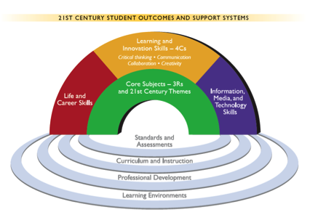
Representation of the distinct but interconnected elements of the P21 framework defined by the Partnership for 21st Century Learning. Source: Partnership for 21st Century Learning 2007.

The P21 elements must be intentionally supported throughout the educational system. The broadest component is the CA NGSS themselves. Many of the SEPs built into the CA NGSS require application of twenty-first-century skills (table 1.14). At a different level, curriculum can provide students opportunities to practice and refine these skills (with feedback) by engaging students in interdisciplinary problems and integrating the use of technologies into solving them. In the classroom, teachers can create a culture that values twenty-first-century skills. In each case, these skills must be explicitly developed within the context of the CA NGSS. Curriculum developers and educators are particularly important for implementing P21 skills that are not already embedded within the three dimensions of the CA NGSS such as social and cross-cultural skills, accountability, leadership, and collaboration. With these efforts in place, the state can more fully achieve the promise of the CA NGSS to prepare the next generation of citizens.

Table 1.14. Relationship between P21 Elements and the CA NGSS
P21 Element | Skills relevant to the P21 Element | Connections with the CA NGSS
Core subjects with twenty-first-century interdisciplinary themes | Global awareness; financial, economic, business, and entrepreneurial literacy; civic literacy; health literacy; and environmental literacy | Financial literacy through defining problems [SEP-1] with cost constraints in engineering design; Environmental Principles and Concepts infused throughout, especially Principle V about decision making in environmental policy.
Life and career skills | Flexibility and adaptability, initiative and self-direction, social and cross-cultural skills, productivity and accountability, and leadership and responsibility | Flexibility and adaptability promoted through constant refinement of models [SEP-2], iterative improvements of engineering designs (ETS1.C), and explicit attention to the Nature of Science, including “Scientific Knowledge is Open to Revision in Light of New Evidence.” Self-direction promoted through an overall student-centered emphasis of the practices such as students learning to ask their own questions [SEP-1], plan their own investigations [SEP-3] and develop their own explanations and solutions [SEP-6].
Learning and innovation skills (the “4C’s”) | Creativity and innovation; communication; collaboration; and critical thinking and problem solving | Engineering design challenges require creative solutions benefit from the diverse ideas of collaborative teams. Communication is an essential part of communicating information [SEP-8] and engaging in argument [SEP-7]
Information, media and technology skills. | Technology proficiency; Information/media literacy. | Obtaining and evaluating information [SEP-8] are both essential media literacy skills.

How to Read the California Next Generation Science Standards
A detailed page describes each standard in the CA NGSS (identical in layout to the national NGSS version). While complex at first glance (figure 1.13), the NGSS authors refer to them as ‘architectures’ because they have a consistent and intentionally defined structure that highlights the three dimensions and provides connections to ensure a coherent curriculum. Each page consists of boxes arranged in four rows (figure 1.14): (1) a title of the core concept being covered; (2) one or more performance expectations; (3) a foundation box containing the three dimensions of the NRC Framework; and (4) a connection box. The Performance Expectations (PEs) are the assessable standards; they are statements that describe what students must actually do in order to demonstrate mastery. Each PE is an expression of all three dimensions, and the box below the PEs articulates which aspects of each dimension are emphasized in each PE. This foundation box has SEPs in the blue section to the left, DCIs in the middle orange section, and CCCs in the green section on the right. The foundation box text comes directly from the NRC Framework. The connection box at the bottom denotes how the PEs connect to other DCIs at this grade level, other grade levels, and to other California standards such as the CA CCSS for ELA/Literacy and Mathematics. The sections that follow provide further guidance about the information in each of the boxes.

Figure 1.13. Example of a Standard Page for Grade 5 and Disciplinary Core Idea PS2, Forces and Interactions.

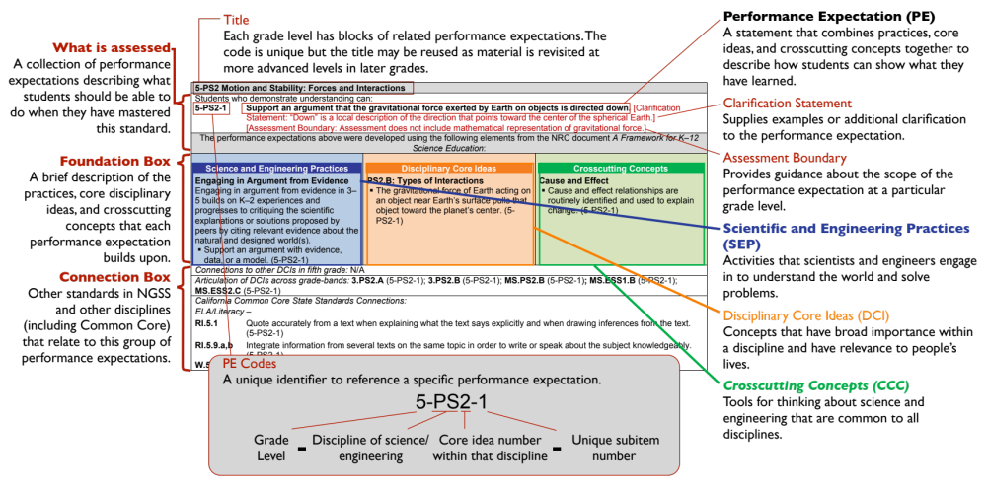
Source: Adapted from National Science Teachers Association 2013.
Figure 1.14. Schematic View of the Layout of Standards in the CA NGSS.

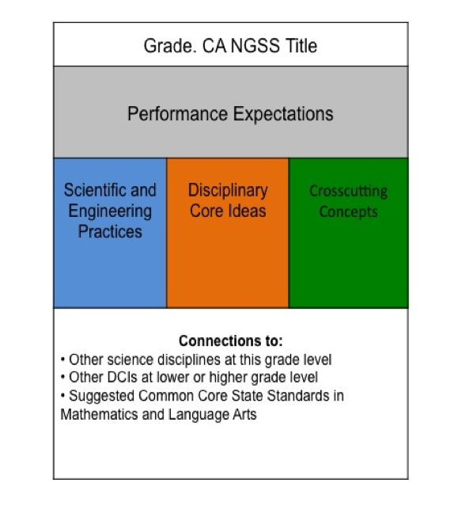

Performance Expectations
The PEs are the assessable statements of what students should be able to accomplish in order to demonstrate understanding of a subject area’s core content. These expectations describe ways that scientifically literate students can express understanding about the world around them and apply that understanding to solve problems in that world. The PEs provide a foundation for advanced science courses such as Advanced Placement, International Baccalaureate, and college-level classes. PEs are not a set of instructional practices, a curriculum, nor actual assessment tasks. Rather, they are general descriptions of what students should be able to perform at the end of instruction. There are many possible ways to assess mastery of a given PE.
Each PE has a unique code with three parts so that it can be referenced concisely. In the PE “5-PS2-1”, the “5” indicates the grade level (a one character abbreviation is used for kindergarten through grade five. “MS” indicates grades six, seven, and eight, and “HS” covers grades nine through twelve). The “PS2” indicates Physical Science core idea number 2 from the list in the NRC Framework (shown in earlier in this chapter), and the “1” refers to the first performance expectation in the series. The wording of PE 5-PS2-1 reveals a three-dimensional combination of a practice (“support an argument”), conceptual ideas (“gravitational force”) and crosscutting concept (“effect”) that students will need to learn and practice during instruction.
A Clarification Statement written in red font often follows the PE to provide the intended interpretation of certain parts of the PE or examples of phenomena. In the PE in figure 1.13, the clarification statement helps teachers understand what is meant by “down”. Also in red is the Assessment Boundary, which clarifies the scope and detail appropriate to this grade level.

Foundation Boxes
Science and Engineering Practices (SEPs): The blue box on the left side of the row of foundation boxes includes only the primary SEPs required for the performance task outlined by the PEs above it. Since PEs often represent the culmination of a long sequence of instruction, students will use other SEPs besides the ones listed in the box. The text in the box that describes the SEPs comes directly from the NRC Framework.
Disciplinary Core Ideas (DCIs): The orange box includes DCIs from the NRC Framework. The box only includes the DCIs most relevant for the student’s understanding of the PE at this grade level, and students will draw on their understanding of other DCIs to accomplish the PE. Because the DCIs are part of a coherent K–12 progression, students will likely draw on prior knowledge of the same DCI from a previous grade level. As such, each PE highlights understanding at an increased depth in each grade level (see appendix 1 of this CA Science Framework).
Crosscutting Concepts (CCCs): The green box provides the major CCCs that are helpful to apply in exploring this disciplinary core idea. This column includes material from the chapter on crosscutting concepts in the NRC Framework, as well as elements of the Engineering, Technology, and Applications of Science (ETS2) core idea and of the nature of science concepts that are important to develop or use in the context of this core idea.
Both the SEP column and the CCC column may also contain supplemental learning goals identified as the “Engineering, Technology, and Application of Science” (found only in the green CCC column) and the “Nature of Science” connections (found both in the SEP and the CCC columns). These additional learning goals are described in the NGSS Appendix H (Nature of Science) and Appendix J (Science, Technology, Society, and the Environment).

Connection Boxes
The connection boxes listed below the foundation boxes are designed to support teachers and curriculum designers in developing a coherent, well integrated curriculum both within science and with other subject areas. The three boxes are: (1) Connections to other DCIs in this Grade Level – to bundle related PEs during curriculum design; (2) Articulation of DCIs across grade levels – to find what students have done on the topic in prior grade levels and recognize what is needed at this grade level to provide a firm foundation for later grades; and (3) Connections to the Common Core State Standards. Tables within the grade level chapters of this document add further connections to CA ELD standards and its EP&Cs.

CA NGSS Appendices
All NGSS Appendices included in the full release of the NGSS materials are a comprehensive resource for further information (located at http://www.nextgenscience.org/get-to-know).

These appendices were adopted as a component of the CA NGSS by the SBE in September 2013 (table 1.15). To minimize confusion, the adopted CA NGSS appendices are indicated by letters and the appendices in this CA Science Framework document are indicated by numbers.

Table 1.15. Summary of the CA NGSS Appendices
# | Appendix Title | Brief Description
A | Conceptual Shifts | Highlights seven “conceptual shifts” science educators and stakeholders need to make to effectively use the NGSS
B | Responses to Public Feedback | Comprehensive summary of all public feedback and responses submitted to Achieve by the NGSS Lead States
C | College and Career Readiness | Reflection on how the standards properly prepare students for college and career readiness
D | All Standards, All Students | Implementation strategies to ensure that all students have equal opportunities
E | Disciplinary Core Idea Progression in the NGSS | Short narrative descriptions of how each DCI progresses in complexity through the grades
F | Scientific and Engineering Practices in the NGSS | Tables for each of the SEPs specifying what students should be able to know and do by the end of each grade-band endpoints.
G | Crosscutting Concepts in the NGSS | Tables for each of the CCCs specifying what the level of understanding appropriate for the end of each grade-band endpoints.
H | Nature of Science in the NGSS | Describes and provides a matrix how the nature of science has been included in both SEPs and CCCs
I | Engineering Design in the NGSS | Describes the CA NGSS’s commitment to integrate engineering design into the structure of science education
J | Science, Technology, Society, and the Environment | Summarizes ETS2, the core ideas that relate science and technology to society and the natural environment
K | Model Course Mapping in Middle and High School | Provides tables with examples of how to organize the standards into grade-level courses for middle and high school that best prepare students for post-secondary success
L | Consistency with the Common Core State Standards for Mathematics | Gives some specific suggestions about the relationship between mathematics and science in K–8. Describes how NGSS was designed so it does not outpace or otherwise misalign to the grade-by-grade CCSS in Mathematics
M | Consistency with the Common Core State Standards for English Language Arts | Identifies key literacy connections to the specific content demands outlined in the CA NGSS. Describes how NGSS was designed so it does not outpace or otherwise misalign to the grade-by-grade CCSS in ELA/Literacy

References

Achieve. 2010. International Science Benchmarking Report: Taking the Lead in Science Education: Forging Next-Generation Science Standards. Washington, D.C.: Achieve.
http://www.achieve.org/files/InternationalScienceBenchmarkingReport.pdf

Achieve. 2016. Using Phenomena in NGSS-Designed Lessons and Units. http://www.nextgenscience.org/sites/default/files/Using%20Phenomena%20in%20NGSS.pdf

American Association for the Advancement of Science. 1993. Benchmarks for Science Literacy. New York: Oxford University Press.

British Energy. N.d. Electric Circuits. http://resources.schoolscience.co.uk/BritishEnergy/11-14/circh1pg3.html

Cheuk, Tina. 2013. Relationships and Convergences among the Mathematics, Science, and ELA Practices. Refined Version of Diagram Created by the Understanding Language Initiative for ELP Standards. Palo Alto, CA: Stanford University.

Clker-Free-Vector-Images. 2012. “Man, Baseball Player, People, Sport.” Posted on Pixabay, https://pixabay.com/en/man-baseball-player-people-sport-31617/

Cinedoku Vorarlberg. 2009. “Hoher Ifen Sommer Kleinwalsertal Bregenzerwald Hanno Thurnher Filmproduktion.” Posted at Wikimedia Commons,
https://commons.wikimedia.org/wiki/File:CINEDOKU_VORARLBERG_Hoher_Ifen_Sommer_Kleinwalsertal_Bregenzerwald_Hanno_Thurnher_Filmproduktion.jpg

Engel, Susan. 2011. “Children’s Need to Know: Curiosity in Schools.” Harvard Educational Review 81 (4): 625–645.

Ford, Danielle J. 2006. “Representations of Science within Children’s Trade Books.” Journal of Research in Science Teaching 43 (2): 214–235.

Ford, Michael J. 2008. “Disciplinary Authority and Accountability in Scientific Practice and Learning.” Science Education 92 (3): 404–423.

Guzetti, Barbara J., Tonja E. Snyder, Gene V. Glass, and Warren S. Gamas. 1993. “Promoting Conceptual Change in Science: A Comparative Meta-Analysis of Instructional Interventions from Reading Education and Science Education.” Reading Research Quarterly 28 (2): 116–161.

Hackling, Mark, and Patrick Garnett. 1992. “Expert–Novice Differences in Science Investigation Skills.” Research in Science Education 22 (1): 170–177.

Lawlor, Debbie A., George Davey Smith, and Shah Ebrahim. 2004. “Commentary: The Hormone Replacement-Coronary Heart Disease Conundrum: Is This the Death of Observational Epidemiology?” International Journal of Epidemiology 33 (3): 464–467.

Lieberman, Gerald. 2013. Education and the Environment: Creating Standards-Based Programs in Schools and Districts. Cambridge, MA: Harvard Education Press.

Livermore Software Technology Corporation. 2017. Livermore, CA. http://www.lstc.com/

Mercer, Neil, Lyn Daws, Roger Wegerif, and Claire Sams. 2004. “Reasoning as a Scientist: Ways of Helping Children to Use Language to Learn Science.” British Education Research Journal 30 (3): 359–377.

National Highway Traffic Safety Association. 2016. 2016 Audi A4 4 DR FWD. https://www.safercar.gov/staticfiles/DOT/safercar/ncapmedia/images/2016/v08024P086.jpg

National Research Council (NRC). 2007. Taking Science to School: Learning and Teaching Science in Grades K–8. Washington, D.C.: The National Academies Press.

———. 2010. Exploring the Intersection of Science Education and 21st Century Skills: A Workshop Summary. Washington, D.C.: The National Academies Press.

———. 2012a. A Framework for K–12 Science Education: Practices, Crosscutting Concepts, and Core Ideas. Committee on a Conceptual Framework for New K–12 Science Education Standards. Board on Science Education, Division of Behavioral and Social Sciences and Education. Washington, D.C.: The National Academies Press.

———. 2012b. Education for Life and Work: Developing Transferable Knowledge and Skills in the 21st Century. Washington, D.C.: The National Academies Press.

———. 2000. Inquiry and the National Science Education Standards: A Guide for Teaching and Learning. Washington, D.C.: The National Academies Press.

National Science Teachers Association. 2013. “Inside the NGSS box.”
http://nstahosted.org/pdfs/ngss/resources/InsideTheNGSSBox.pdf

NGSS Lead States. 2013a. http://nextgenscience.org/

———. 2013b. Appendix B. Responses to the Public Drafts. http://www.nextgenscience.org/sites/ngss/files/Appendix%20B%20-%20Responses%20to%20the%20Public%20Drafts.pdf

Norris, Stephen P., and Linda Phillips. 2003. “How Literacy in its Fundamental Sense is Central to Scientific Literacy.” Science Education 87 (2): 224–240.

Ogborn, Jon, Gunther Kress, Isabel Martins, and Kieran McGillicuddy. 1996. Explaining Science in the Classroom. Buckingham: Open University Press.

Osborne, Jonathan F. 2010. “Arguing to Learn in Science: The Role of Collaborative, Critical Discourse.” Science 328 (5977): 463–466.

Partnership for 21st Century Learning (P21). 2007. Framework for 21st Century Learning. http://www.p21.org/our-work/p21-framework
Passmore, Cynthia, Julia Svoboda Gouvea, and Ronald Giere. 2014. “Models in Science and in Learning Science: Focusing Scientific Practice on Sense-Making.” In International Handbook of Research in History, Philosophy, and Science Teaching, edited by Michael R. Matthews. Dordrecht: Springer.

Poincaré, Jules Henri. 1905. Science and Hypothesis. London: Walter Scott Publishing.

Project 2061 (American Association for the Advancement of Science). 1989. Science for All Americans: A Project 2061 Report on Literacy Goals in Science, Mathematics, and Technology. Washington, D.C.: American Association for the Advancement of Science.

Science Buddies. 2015. “The Effect of Bridge Design on Weight Bearing Capacity.” http://www.sciencebuddies.org/science-fair-projects/project_ideas/CE_p011.shtml

Tenopir, Carol, and Donald W. King. 2004. Communication Patterns of Engineers. Hoboken, New York: Wiley.

State of Victoria (Department of Education and Training). 2014. Electric Circuits. http://www.education.vic.gov.au/school/teachers/teachingresources/discipline/science/continuum/Pages/electriccircuit.aspx?Redirect=1

Willett, Sean D. 1999. "Orogeny and Orography: The Effects of Erosion on the Structure of Mountain Belts." Journal of Geophysical Research: Solid Earth 104 (B12): 28957-28981.

Wing, Jeannette M. 2006. "Computational Thinking." Communications of the ACM 49 (3): 33–35.

Zohar, Anat, and Flora Nemet. 2002. “Fostering Students’ Knowledge and Argumentation Skills through Dilemmas in Human Genetics.” Journal of Research in Science Teaching 39 (1): 35–62.

The complete listing of California’s EP&Cs, including the detailed concepts, is provided in: California Education and the Environment Initiative. 2016. California’s Environmental Principles and Concepts. http://californiaeei.org/framework/sci/EPC
The term “augment” is used because no reason was found to alter the CA ELD Standards as they are currently written; it was determined to be valuable to augment them with materials that illustrate more explicitly the connection of the ELD Standards to the language demands found in mathematics and science content standards.

